**CERTIFICATE**

This is to certify that the project report titled “Analysis of nozzle flow,” submitted by Ishika, meets the requirements for the internship in the Bachelor of Technology in Aerospace Engineering program at the Terminal Ballistics Research Laboratory (TBRL), DRDO, Sector-30, Chandigarh.

Ms. Ishika has demonstrated exceptional dedication, creativity, and technical proficiency in her work. Her project showcases a high level of originality and innovation, reflecting her commitment to excellence. The meticulous research, thorough analysis, and practical application of deep learning techniques in her project are commendable.

To the best of my knowledge, this project report has not been submitted, either partially or in its entirety, elsewhere in any other university or institution for the award of an internship certificate.

Subhash Chander(Scientist 'F')

RTRS, TBRL

**DECLARATION**

I, Ishika student of 8 th semester B. Tech in Aerospace Engineering, at Faculty of Engineering & Technology, JAIN (Deemed-to-be University), hereby declare that the Project titled “Analysis of Nozzle Flow” has been carried out by me and submitted in partial fulfillment for the award of degree in Bachelor of Technology in Aerospace Engineering during the academic year 2023-2024. Further, the matter presented in the project has not been submitted previously by anybody for the award of any degree or any diploma to any other University, to the best of our knowledge and faith.

Signature:

Ishika

Date:

Place:Chandigarh

**ACKNOWLEDGEMENT**

I wish to extend my sincere appreciation to Dr. M Raghavendra Rao, Director , TBRL, Chandigarh, for granting me the opportunity to undertake my internship at TBRL.

I am deeply indebted to Mr. A.C. Sharma (Scientist ‘H’,Group Director,RTRS),for his unwavering motivation and support throughout this endeavor.

My heartfelt gratitude goes to my supervisor, Mr. Sandeep Malik (Scientist 'G', Joint Director, RTRS), and my mentor Mr. Subhash Chander(Scientist 'F'), for their unwavering support, invaluable guidance, and timely assistance throughout my internship. Despite their demanding schedules and departmental commitments, they generously dedicated their time to provide me with direction and knowledge, ensuring my progress on the right trajectory.

Additionally, I am thankful to the staff of the RTRS department at TBRL for their assistance.

Furthermore, I express my profound gratitude to Professor Dr Amlesh Barai of the Aerospace Engineering Department at the Jain(Deemed-to-be-University), Bangalore, for his significant contributions to the completion of my project titled "Analysis of Nozzle Flow."

Lastly, I would like to affirm that this project was completed solely by myself.

Signature

ISHIKA

**ABSTRACT**

The exhaust nozzle is an integral part of a rocket engine and critical to its overall system performance. Challenges associated with the design and manufacturing of an exhaust nozzle become greater as the cruise speed of the rocket increases. The exhaust nozzle of a supersonic cruise aircraft requires additional capabilities such as variable throat and exit area, noise suppression, and reverse thrust. The present work is an effort to study the design and analysis of rocket nozzles.

In the present work, modeling and analysis are carried out using ANSYS DESIGN MODELER and Fluent solver in order to understand the fluid flow characteristics.

The focus of our project is to check the exit Mach number of a convergent divergent Supersonic nozzle reaches to greater than Mach 2.

Present simulation work is carried on different cross-sections like circle, square and rectangle and the best cross-section will be declared.

**TABLE OF CONTENTS**

Abstract

1. Introduction to Organisation
2. TBRL(Terminal Ballistics Research Facility)
3. RTRS (National Testing Facility)
4. Introduction to Nozzles
5. Convergent Divergent Nozzle
6. Flow analysis in 2D nozzle
7. Flow analysis in 3D nozzle
8. Minimizing the interference of 3D nozzle flow

**LIST OF FIGURES**

| **Fig. No.** | **Description of the figure** | **Page No.** |
| --- | --- | --- |
| Fig. 4.1 | Typical aircraft nozzle |  |
| Fig. 4.2 | Convergent nozzle |  |
| Fig. 4.3 | Divergent nozzle |  |
| Fig. 5.1 | Cross section diagram of nozzle |  |
| Fig. 6.1 | Diagram of 2D nozzle |  |
| Fig. 6.2 | Nozzle imported geometry |  |
| Fig. 6.3 | Face meshing across all boundaries |  |
| Fig. 6.4 | Sizing of nozzle |  |
| Fig. 6.5 | 2D meshed surface |  |
| Fig. 6.6 | Name selection of nozzle |  |
| Fig. 6.7 | Processors used |  |
| Fig. 6.8 | Material selection |  |
| Fig. 6.9 | Boundary conditions |  |
| Fig. 6.10 | Pressure condition |  |
| Fig. 6.11 | Parameters for nozzle |  |
| Fig. 6.12 | Velocity and energy conditions |  |
| Fig. 6.14 | Mach number contour |  |
| Fig. 6.15 | Pressure contour |  |
| Fig. 7.1 | 3D nozzle design |  |
| Fig. 7.2 | 3D nozzle with domain |  |
| Fig. 7.3 | Triangular mesh |  |
| Fig. 7.4 | Processors used |  |
| Fig. 7.5 | Solver setup |  |
| Fig. 7.6 | Models used |  |
| Fig. 7.7 | Properties of the material |  |
| Fig. 7.8 | Pressure and temperature allotment |  |
| Fig. 7.9 | Reference values |  |
| Fig. 7.10 | Continuity along x,y and z axis |  |
| Fig. 7.11 | Initialization |  |
| Fig. 7.13 | Velocity contour |  |
| Fig. 7.14 | Pressure contour |  |
| Fig. 7.15 | Temperature contour |  |
| Fig. 7.16 | Density contour |  |
| Fig. 7.17 | Velocity streamlines |  |
| Fig. 8.1 |  |  |
| Fig. 8.2 |  |  |
| Fig. 8.3 |  |  |
| Fig. 8.4 |  |  |

**LIST OF GRAPHS**

| **Graph No.** | **Description of the graph** | **Page No.** |
| --- | --- | --- |
| Graph 6.13 | Iteration graph of 2D nozzle |  |
| Graph 7.12 | Iteration graph for 3D nozzle |  |
| Graph |  |  |
| Graph |  |  |
| Graph |  |  |
| Graph |  |  |

**CHAPTER 1**

**INTRO TO ORGANISATION**

The Defence Research and Development Organisation (DRDO) is an agency of the Government of India, charged with the military's research and development. Established in 1958, it operates under the Ministry of Defence and is responsible for enhancing the country's self-reliance in defense technologies and systems.

**VISION AND MISSION**

1.Mission: DRDO's primary mission is to develop cutting-edge defense technologies and systems to strengthen India's national security and defense capabilities across land, sea, and air domains.

2.Research and Development: DRDO undertakes a wide range of research and development activities encompassing various fields such as aeronautics, armaments, electronics, combat vehicles, missiles, naval systems, and life sciences.

3.Laboratories and Centers: DRDO operates a network of specialized laboratories and research centers across India, each focusing on specific areas of defense research and technology development. Some of the prominent ones include the Aeronautical Development Establishment (ADE), Defence Research and Development Laboratory (DRDL), Electronics and Radar Development Establishment (LRDE), and Defence Bioengineering and Electro-medical Laboratory (DEBEL).

4.Collaborations and Partnerships: DRDO collaborates extensively with other government agencies, academic institutions, and industries both within India and internationally to leverage expertise, resources, and technologies for defense research and development projects.

5.Product Development and Indigenous Production: One of DRDO's key objectives is to facilitate the indigenous development and production of defense equipment, systems, and platforms to reduce dependency on foreign suppliers and enhance self-reliance in defense production.

6.Achievements: Over the years, DRDO has made significant contributions to India's defense capabilities, including the development of strategic missile systems like Agni, Prithvi, and BrahMos, the Light Combat Aircraft (LCA) Tejas, various radars, electronic warfare systems, and indigenous armored vehicles.

7.Technology Transfer and Spin-offs: DRDO also focuses on technology transfer and spin-offs, facilitating the transfer of defense technologies to civilian applications and industries to promote economic growth and innovation.

Overall, DRDO plays a pivotal role in advancing India's defense technology landscape, contributing to the country's security, sovereignty, and technological advancement.

**CHAPTER 2**

**TBRL(Terminal Ballistics Research Laboratories)**

TBRL stands for Terminal Ballistics Research Laboratory. It is one of the premier laboratories under the Defence Research and Development Organisation (DRDO) of India. The primary focus of TBRL is on research and development related to terminal ballistics, which involves the study of the behavior and effects of projectiles, explosives, and warheads upon impact with targets.

**MISSION AND VISION OF TBRL**

1.Mission: TBRL's mission is to conduct research and development activities in the field of terminal ballistics to enhance the effectiveness of munitions, projectiles, and warheads used by the Indian Armed Forces.

2.Research Areas: TBRL conducts research in various aspects of terminal ballistics, including the design, development, and testing of ammunition, explosives, and warheads. This involves studying the behavior of materials under high-velocity impact, fragmentation patterns, blast effects, and penetration capabilities.

3.Facilities: TBRL is equipped with state-of-the-art facilities for conducting experiments, simulations, and testing related to terminal ballistics. These facilities include ballistic ranges, high-speed cameras, computer simulation laboratories, and specialized testing equipment.

4.Collaborations: TBRL collaborates with other DRDO laboratories, academic institutions, and defense establishments to leverage expertise and resources in related fields. Collaborative efforts enable TBRL to undertake multidisciplinary research projects and address complex challenges in terminal ballistics.

5.Technology Development: TBRL works towards the development of advanced technologies and methodologies for improving the performance, precision, and lethality of munitions and warheads used in various defense applications.

6.Support to Armed Forces: TBRL provides technical support and expertise to the Indian Armed Forces in the areas of terminal ballistics, including the evaluation of ammunition, warheads, and explosives, as well as the development of specialized munitions for specific operational requirements.

7.Contribution to National Security: The research and development activities carried out by TBRL contribute to enhancing India's defense capabilities, ensuring the effectiveness and reliability of munitions and warheads used by the Armed Forces in various combat scenarios.

In summary, TBRL plays a crucial role within the DRDO ecosystem by focusing on the specialized field of terminal ballistics, contributing to the development of advanced technologies and solutions to meet the defense needs of the nation.

**RESEARCH AND DEVELOPMENT AT TBRL**

Terminal Ballistics Research Laboratory (TBRL), which is part of India's Defence Research and Development Organisation (DRDO), possesses a range of state-of-the-art research and development facilities. These facilities are dedicated to conducting experiments, simulations, and testing in the field of terminal ballistics, which involves studying the behavior and effects of projectiles, explosives, and warheads upon impact with targets.

Some of the key R&D facilities at TBRL are:

1.Ballistic Ranges: TBRL is equipped with multiple ballistic ranges that enable researchers to conduct experiments to study the flight characteristics, trajectory, and impact behavior of projectiles, missiles, and warheads under various conditions.

2.High-Speed Cameras: High-speed cameras are essential tools for capturing detailed imagery of fast-moving objects during impact and explosion events. TBRL utilizes advanced high-speed camera systems to analyze the behavior of projectiles and explosives at extremely high frame rates.

3.Computer Simulation Laboratories: TBRL maintains computer simulation laboratories equipped with specialized software and hardware for modeling and simulating terminal ballistics phenomena. These simulations help researchers understand complex interactions between projectiles, targets, and explosives, aiding in the design and optimization of munitions and warheads.

4.Explosive Testing Facilities: TBRL houses facilities for testing and evaluating different types of explosives used in warheads and ammunition. These facilities include blast chambers, fragmentation test rigs, and instrumentation for measuring blast effects and explosive performance.

5.Materials Testing Laboratories: TBRL conducts research on the behavior of materials under high-velocity impact conditions. Materials testing laboratories are equipped with instruments for characterizing the mechanical properties, fragmentation patterns, and penetration resistance of various materials used in armor, projectiles, and targets.

6.Instrumentation and Measurement Systems: TBRL utilizes advanced instrumentation and measurement systems for collecting data during experiments and tests. These systems include sensors, data acquisition units, and signal processing equipment for monitoring parameters such as velocity, acceleration, pressure, and temperature.

7.Chemical Analysis and Forensic Laboratories: TBRL maintains chemical analysis and forensic laboratories for analyzing the composition and properties of explosives, propellants, and other materials used in munitions and warheads. These laboratories employ techniques such as spectroscopy, chromatography, and microscopy for forensic analysis and quality control.

Overall, the R&D facilities at TBRL are geared towards advancing the understanding of terminal ballistics phenomena and developing innovative technologies for enhancing the effectiveness and lethality of defense munitions and warheads. These facilities play a crucial role in supporting India's defense research and development efforts and ensuring the country's security and sovereignty.

**TBRL ACHIEVEMENTS**

The Terminal Ballistics Research Laboratory (TBRL), a part of India's Defence Research and Development Organisation (DRDO), has made significant achievements in the field of terminal ballistics, contributing to the enhancement of India's defense capabilities. Some of TBRL's notable achievements include:

1.Development of Advanced Warheads: TBRL has been instrumental in developing advanced warheads for various types of munitions and missiles used by the Indian Armed Forces. These warheads are designed to maximize lethality and effectiveness against a wide range of targets, including armored vehicles, bunkers, and fortified structures.

2.Enhancement of Missile Systems: TBRL has played a key role in enhancing the performance of missile systems by developing specialized warheads and payload technologies. This includes the development of high-explosive, fragmentation, and penetrator warheads for surface-to-surface and surface-to-air missiles, increasing their precision and lethality.

3.Improvement of Ammunition: TBRL has contributed to the improvement of ammunition for artillery, tank guns, and small arms by developing advanced terminal ballistics technologies. This includes the development of specialized ammunition variants optimized for specific operational requirements, such as armor-piercing, high-explosive, and multipurpose rounds.

4.Research on Blast and Fragmentation Effects: TBRL conducts extensive research on blast and fragmentation effects to understand the behavior of explosives and warheads upon detonation. This research helps in optimizing the design of warheads and explosive payloads to maximize their destructive potential while minimizing collateral damage.

5.Development of Blast Mitigation Technologies: TBRL has developed blast mitigation technologies aimed at improving the survivability of military personnel and equipment in explosive environments. This includes the development of blast-resistant materials, structures, and protective systems to minimize the impact of explosions on military vehicles and installations.

6.Contribution to Indigenous Weapon Systems: TBRL's research and development efforts have contributed to the indigenous development of weapon systems and platforms, including tanks, aircraft, and naval vessels. By providing advanced terminal ballistics technologies, TBRL has enabled the integration of lethal and accurate weapon systems into the Indian Armed Forces' inventory.

7.Collaboration and Technology Transfer: TBRL collaborates with other DRDO laboratories, academic institutions, and defense establishments to leverage expertise and resources in related fields.

**CHAPTER 3**

**RTRS(RAIL TRACK ROCKET SLED)**

**NATIONAL TESTING FACILITY**

RTRS stands for Rail Track Rocket Sled, which is a facility of the Defence Research and Development Organisation (DRDO) of India. Specifically, it's part of the Terminal Ballistics Research Laboratory (TBRL), which is located in Chandigarh, India.

Some Key Features:

* 1.Rocket Testing Facility: RTRS is primarily dedicated to testing rockets and rocket-related technologies developed by DRDO. This includes various types of rocket motors, propulsion systems, and related components.
* 2.Test Infrastructure: RTRS is equipped with specialized test infrastructure designed to accommodate rocket testing activities. This infrastructure includes test stands, control systems, instrumentation, and safety measures necessary for conducting rocket tests safely and effectively.

3.Rocket Motor Development: RTRS supports the development and evaluation of rocket motors used in a wide range of applications, including tactical missiles, surface-to-air missiles, anti-tank guided missiles, and other defense systems.

* 4.Performance Evaluation: RTRS conducts performance evaluation tests to assess the capabilities and characteristics of rocket motors under different operating conditions. These tests help in validating design parameters, optimizing performance, and ensuring reliability and safety.
* 5.Research and Development: RTRS contributes to the research and development efforts of DRDO in the field of rocket propulsion and related technologies. It collaborates with other DRDO laboratories and research institutions to advance the state-of-the-art in rocket propulsion systems.
* 6.Integration and Testing: RTRS plays a critical role in the integration and testing of rocket motors with various missile systems and platforms developed by DRDO. This includes conducting ground tests to verify performance and compatibility before missile systems are deployed for field trials or operational use.
* 7.Technology Innovation: RTRS focuses on technology innovation and continuous improvement to enhance the performance, efficiency, and reliability of rocket propulsion systems. It explores new materials, designs, and manufacturing processes to meet the evolving requirements of India's defense forces.

RTRS at TBRL serves as a key facility for testing and evaluating rocket propulsion systems developed by DRDO. It supports the organization's mission to strengthen India's defense capabilities and enhance self-reliance in critical defense technologies.

**ACHIEVEMENTS AT RTRS**

The Rocket Testing Range Station (RTRS) at the Terminal Ballistics Research Laboratory (TBRL), part of India's Defence Research and Development Organisation (DRDO), has achieved several significant milestones in rocket propulsion testing and related technologies.

Some of RTRS notable achievements include:

1.Successful Testing of Rocket Motors: RTRS has conducted numerous successful tests of rocket motors for various types of missiles and rocket systems developed by DRDO. These tests include static firings and dynamic evaluations to validate the performance, reliability, and safety of rocket propulsion systems under simulated operating conditions.

2.Development of Advanced Rocket Propulsion Technologies: RTRS has contributed to the development of advanced rocket propulsion technologies, including solid, liquid, and hybrid rocket motors. These technologies are aimed at enhancing the range, accuracy, and lethality of missile systems used by the Indian Armed Forces.

3.Validation of Indigenous Missile Systems: RTRS has played a pivotal role in the validation and qualification of indigenous missile systems developed by DRDO. This includes testing the propulsion systems of strategic and tactical missiles, such as surface-to-air missiles, anti-tank guided missiles, and ballistic missiles, to ensure their performance meets operational requirements.

4.Integration Support for Missile Programs: RTRS provides integration support for missile programs undertaken by DRDO, facilitating the seamless integration of rocket propulsion systems with missile airframes, guidance systems, and warhead payloads. This integration ensures the compatibility and effectiveness of missile systems during flight and engagement with targets.

5.Contribution to National Security: The testing and validation activities conducted by RTRS contribute to enhancing India's national security by strengthening the country's indigenous capabilities in missile technology development and production. RTRS's achievements support India's strategic deterrence posture and defense preparedness against potential threats.

6.Technology Innovation and Optimization: RTRS focuses on continuous innovation and optimization of rocket propulsion technologies to improve performance, reliability, and cost-effectiveness. Research efforts at RTRS explore advanced materials, manufacturing processes, and propulsion concepts to meet the evolving requirements of modern missile systems.

7.Collaboration and Knowledge Sharing: RTRS collaborates with other DRDO laboratories, academic institutions, and industry partners to exchange knowledge, expertise, and best practices in rocket propulsion testing and technology development. This collaboration enhances the collective capabilities of the Indian defense research and development community in advancing rocket propulsion technology.

Overall, the achievements of RTRS at TBRL underscore its critical role in advancing India's indigenous missile technology capabilities and strengthening the country's defense infrastructure. RTRS's contributions support DRDO's mission of achieving self-reliance in critical defense technologies and bolstering India's defense preparedness.

**CHAPTER 4**

**INTRODUCTION TO NOZZLES**

Aircraft nozzles are critical components of propulsion systems, particularly in jet engines. They play a crucial role in the efficient conversion of high-pressure gases generated by the engine into thrust, which propels the aircraft forward.

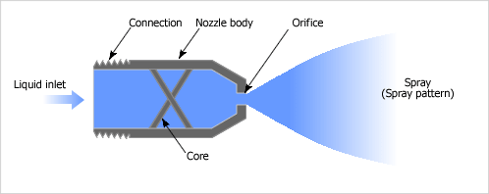

Fig. 4.1

**TYPES OF NOZZLES**

There are several types of aircraft nozzles, each designed to suit different engine configurations and performance requirements:

1.Exhaust Nozzles: These are the most common type of aircraft nozzles found in jet engines. They are responsible for channeling and directing the hot exhaust gases produced by the engine's combustion process. Exhaust nozzles can vary in design, including convergent, divergent, or convergent-divergent configurations, depending on the engine's requirements for subsonic, supersonic, or transonic flight regimes.

2.Variable Geometry Nozzles: Some modern aircraft employ variable geometry nozzles that can adjust their shape and area to optimize engine performance across different operating conditions. These nozzles can alter their geometry to control exhaust flow properties, such as pressure, velocity, and direction, thereby improving fuel efficiency, thrust output, and noise levels.

3.Thrust Reverser Nozzles: In addition to providing forward thrust, aircraft engines equipped with thrust reverser systems utilize specialized nozzles to redirect exhaust flow forward during landing, effectively creating reverse thrust. This capability assists in decelerating the aircraft upon touchdown, enhancing braking efficiency and shortening landing distances.

4.Afterburner Nozzles: Afterburner nozzles are specific to engines equipped with afterburner or "reheat" systems, commonly found in military aircraft. These nozzles facilitate the injection of additional fuel into the exhaust stream downstream of the primary combustion chamber, generating a significant increase in thrust output for high-performance maneuvers and supersonic flight.

5.Auxiliary Power Unit (APU) Exhaust Nozzles: Aircraft equipped with auxiliary power units feature dedicated exhaust nozzles for expelling the hot gases produced by the APU during ground operations. These nozzles are designed to ensure efficient dispersion of exhaust gases while minimizing environmental impact and maintaining safety standards on the ground.

Aircraft nozzles are diverse in design and function, tailored to meet the specific requirements of different propulsion systems and operational scenarios encountered in aviation. They represent integral components of aircraft engines, contributing to overall performance, efficiency, and safety during flight.

**CONVERGENT NOZZLE**

A convergent nozzle is a component commonly used in fluid mechanics, particularly in the field of aerospace engineering and propulsion systems. It is a duct or passage that narrows down gradually in one direction. The purpose of a convergent nozzle is to accelerate the flow of a fluid (usually a gas) passing through it by converting pressure energy into kinetic energy.

Some key points are:

* Principle of Operation: As the fluid flows through the convergent section of the nozzle, its velocity increases while the pressure decreases. This acceleration is due to the converging shape of the nozzle, which causes the fluid to speed up as it passes through the narrower section.
* Applications:

1.Jet Engines and Rockets: Convergent nozzles are used in jet engines and rocket propulsion systems to accelerate the exhaust gases expelled from the combustion chamber. The increased velocity of the exhaust gases produces thrust according to Newton's third law of motion.

2.Wind Tunnels: Convergent nozzles are also used in wind tunnels to generate high-speed airflow for testing aerodynamic properties of objects like aircraft, cars, or buildings.

3.Throat: The narrowest point in a convergent nozzle is called the throat. It is at this point that the flow velocity is at its highest and the pressure is at its lowest.

4.Choked Flow: When the fluid velocity at the throat reaches the speed of sound, the flow is said to be "choked." At this point, further reductions in downstream pressure will not increase the flow rate.

5.Design Considerations: The design of convergent nozzles involves considerations such as fluid properties, desired flow velocity, and pressure conditions at the inlet and outlet of the nozzle.

Convergent nozzles are essential components in various engineering applications where the controlled acceleration of fluid flow is necessary for propulsion, testing, or other purposes.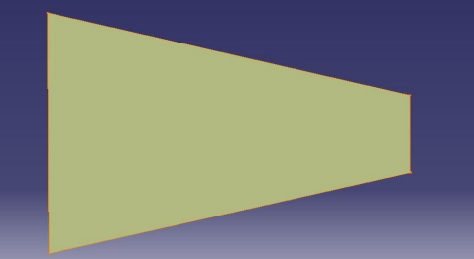

Fig. 4.2

**DIVERGENT NOZZLE**

A divergent nozzle is another important component in fluid mechanics, particularly in aerospace engineering and propulsion systems. Unlike a convergent nozzle, which narrows down gradually, a divergent nozzle expands gradually in one direction. Divergent nozzles are often used in conjunction with convergent nozzles to optimize the flow of fluids, usually gases, in various applications.

Some key points are:

* Principle of Operation: As the fluid flows through the divergent section of the nozzle, its velocity decreases while the pressure increases. This expansion of the flow causes the fluid to slow down and the pressure to rise.

Applications:

* 1.Rocket Engines: Divergent nozzles are commonly used in rocket engines. After the combustion of propellant in the combustion chamber, the hot gases expand rapidly into the divergent nozzle. As the gases expand, they push against the diverging walls, which further accelerates the gases in the opposite direction, producing thrust.
* 2.Supersonic Wind Tunnels: Divergent nozzles are used to decelerate supersonic airflow in wind tunnels. By gradually expanding the flow, the nozzle helps to reduce the speed of the airflow to subsonic levels, allowing for aerodynamic testing at lower speeds.
* 3.Throat: Similar to convergent nozzles, a divergent nozzle also has a throat, which is the narrowest point in the nozzle. The throat marks the transition between the convergent and divergent sections.
* 4.Expansion Ratio: The ratio of the exit area of the nozzle to the throat area is known as the expansion ratio. This ratio is a critical parameter in the design of divergent nozzles and affects the performance of propulsion systems.
* 5.Design Considerations: Designing a divergent nozzle involves considerations such as the desired exit velocity, pressure conditions at the inlet and exit of the nozzle, and the characteristics of the fluid being used.
* Divergent nozzles play a crucial role in various engineering applications where controlled expansion of fluid flow is necessary for propulsion, testing, or other purposes.

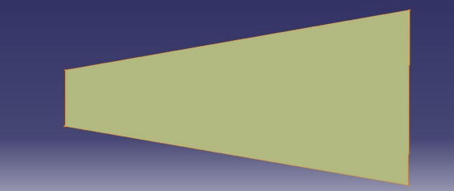

Fig. 4.3

**CONVERGENT DIVERGENT NOZZLE(C-D)**

A convergent-divergent (CD) nozzle, also known as a de Laval nozzle, is a specially designed nozzle used in various propulsion systems, particularly in rocket engines and supersonic air-breathing engines. It consists of three main sections: a convergent section, a throat, and a divergent section.

Some key points are:

1.Function: Convergent-divergent nozzles are designed to accelerate the flow of a fluid (typically gas) to supersonic velocities by converting the pressure energy of the fluid into kinetic energy. They are crucial components in propulsion systems where high velocities are required, such as rocket engines and supersonic aircraft.

2.Design: The nozzle typically consists of three sections: the convergent section, the throat, and the divergent section. The convergent section gradually narrows the flow area, increasing the fluid velocity and reducing its pressure. The throat is the narrowest point of the nozzle where the flow velocity reaches its maximum value. The divergent section then expands the flow, further accelerating it to supersonic speeds.

3.Critical Role in Rocket Engines: In rocket engines, the convergent-divergent nozzle is essential for efficient thrust generation in vacuum conditions. As the exhaust gases expand through the divergent section, they achieve supersonic speeds, maximizing thrust according to the rocket equation.

4.Choked Flow: At the throat of the nozzle, the flow velocity reaches the speed of sound (Mach 1), and the flow is said to be "choked." This condition is critical for achieving maximum efficiency in convergent-divergent nozzles.

5.Applications: Convergent-divergent nozzles are used in various applications, including rocket engines for space launch vehicles, supersonic and hypersonic aircraft engines, and certain industrial processes where high-speed gas flow is required.

6.Aerodynamic Considerations: Designing convergent-divergent nozzles involves careful consideration of aerodynamic principles, including shock waves, expansion fans, and flow separation, to ensure efficient and stable operation across a range of operating conditions.

7.Thrust Vectoring: In some applications, such as advanced rocket engines and fighter jets, convergent-divergent nozzles may be equipped with thrust vectoring mechanisms to control the direction of thrust for enhanced maneuverability.

8.Efficiency and Performance: The efficiency and performance of convergent-divergent nozzles depend on factors such as the design parameters (including the ratio of throat area to exit area), operating conditions, and the properties of the fluid being accelerated.

Understanding the principles and operation of convergent-divergent nozzles is essential for engineers and researchers working in fields related to propulsion, aerodynamics, and fluid mechanics.

**CHAPTER 5**

**CONVERGENT DIVERGENT NOZZLE**

**(C-D NOZZLE)**

A convergent-divergent nozzle, also known as a de Laval nozzle, is a critical component in many propulsion systems, especially those used in rockets and jet engines. It's designed to accelerate the flow of a fluid, typically a gas like air or a propellant such as liquid fuel or a gas like hydrogen, to supersonic speeds.

Here's how it works:

1.Convergent Section: The nozzle starts with a convergent section, where the cross-sectional area decreases along the flow direction. This accelerates the flow while increasing its velocity.

2.Throat: The throat is the narrowest part of the nozzle. At this point, the flow reaches its maximum velocity, which is typically supersonic.

3.Divergent Section: Following the throat, the nozzle expands in a divergent section, where the cross-sectional area increases. This further accelerates the flow and converts its velocity into pressure, maintaining the high speed.

The convergent section initially speeds up the flow by compressing it, raising its velocity. Then, the divergent section allows the flow to expand, converting the velocity into pressure, which is critical for providing thrust in propulsion systems.

These nozzles are used in various applications, such as rocket engines, where high velocities and thrust are essential for efficient propulsion. They're also used in supersonic and hypersonic wind tunnels for aerodynamic testing.

**WORKING OF CONVERGENT DIVERGENT NOZZLE**

The working principle of a convergent-divergent (CD) nozzle involves the transformation of pressure energy into kinetic energy and then back into pressure energy. Here's a detailed explanation of its operation:

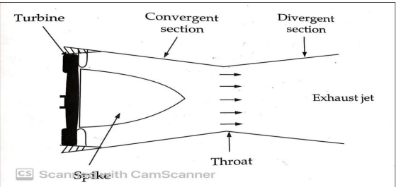

Fig. 5.1

1.Convergent Section:

* The convergent section of the nozzle is where the flow initially accelerates. It is designed with a decreasing cross-sectional area in the direction of flow.
* As the flow enters the convergent section, the nozzle's geometry causes the fluid to accelerate due to the decreasing area. This acceleration increases the flow velocity and decreases the pressure of the fluid.

2.Throat:

* The throat is the narrowest part of the nozzle. At this point, the flow reaches its maximum velocity. This maximum velocity occurs because the convergent section has accelerated the flow to its sonic speed, also known as the speed of sound.
* The throat area is critical because it establishes the maximum mass flow rate through the nozzle. It's where the flow becomes choked, meaning it cannot accelerate further even if the downstream pressure decreases.

3.Divergent Section:

* Beyond the throat, the nozzle diverges, meaning the cross-sectional area increases. This section is called the divergent section.
* As the flow enters the divergent section, the increasing area causes the flow velocity to further increase beyond the speed of sound. This acceleration continues, and the flow velocity becomes supersonic.
* The supersonic flow in the divergent section converts the kinetic energy of the flow back into pressure energy. This conversion happens due to the decrease in velocity and the increase in pressure.
* By the end of the divergent section, the flow has reached a high velocity, and the pressure has increased significantly compared to the throat.

The key to the efficiency of the CD nozzle is its ability to convert the high-velocity, low-pressure flow from the convergent section into high-pressure, high-velocity flow in the divergent section. This conversion is crucial for generating thrust in propulsion systems like rocket engines.

**SIGNIFICANCE OF CONVERGENT DIVERGENT NOZZLE**

Convergent-divergent (CD) nozzles hold significant importance in various fields, primarily in propulsion systems and fluid dynamics. Here are some of their key significances:

1.Efficient Propulsion:

* CD nozzles are integral components of rocket engines, where they efficiently convert the high-pressure, high-temperature gases produced by combustion into high-velocity exhaust jet.
* By accelerating the exhaust gases to supersonic speeds, CD nozzles maximize thrust and efficiency, crucial for achieving high-performance rocket propulsion.

2.Supersonic and Hypersonic Flight:

* CD nozzles are essential in supersonic and hypersonic aircraft engines for generating thrust and maintaining efficient airflow at high speeds.
* They enable aircraft to achieve and sustain supersonic and hypersonic speeds by efficiently expanding and accelerating the airflow.

3.Aerodynamic Testing:

* CD nozzles are utilized in supersonic and hypersonic wind tunnels for aerodynamic testing of aircraft, missiles, and spacecraft.
* They create high-speed airflow simulating real-life conditions, allowing engineers to study aerodynamic behaviors, evaluate designs, and validate computational models.

4.Space Exploration:

* In space exploration, CD nozzles play a critical role in rocket propulsion systems for launching spacecraft, controlling their trajectories, and performing maneuvers.
* They enable spacecraft to overcome Earth's gravity, reach orbit, and travel through space efficiently.

5.Energy Production:

* CD nozzles are used in certain types of power generation systems, such as steam turbines and hydroelectric power plants, to efficiently convert the kinetic energy of fluid flow into mechanical energy.
* They optimize the flow of fluids to maximize energy output and improve the overall efficiency of power generation processes.

6.Medical Applications:

* In medical devices like nebulizers and aerosol drug delivery systems, CD nozzles are used to generate fine aerosol sprays for inhalation therapy.
* They help in delivering medication directly to the lungs, ensuring effective treatment for respiratory conditions.

Overall, convergent-divergent nozzles are essential components in various applications where efficient fluid flow control, high-speed propulsion, and aerodynamic performance are crucial.

**CHAPTER 6**

**FLOW ANALYSIS IN 2D NOZZLE**

Analyzing a nozzle in 2D flow using Computational Fluid Dynamics (CFD) involves similar steps to the 3D case but with some simplifications due to the reduced dimensionality:

1.Geometry Creation: Create a 2D model of the nozzle geometry. This can be done using CAD software, with the geometry constrained to a 2D plane.

2.Mesh Generation: Generate a 2D mesh for the computational domain. In 2D simulations, the mesh is essentially a grid of cells covering the nozzle geometry and surrounding flow domain.

3.Boundary Conditions: Define the boundary conditions for the 2D simulation, similar to the 3D case. Specify inlet conditions, outlet conditions, and wall conditions.

4.Fluid Properties: Specify the properties of the fluid being used in the simulation, such as density, viscosity, and any other relevant properties.

5.Solver Setup: Choose an appropriate solver for 2D flow simulations. Set up the simulation parameters, including turbulence models (if applicable), discretization schemes, and convergence criteria.

6.Run Simulation: Run the 2D CFD simulation and monitor its progress. Since 2D simulations are computationally less expensive than 3D simulations, the simulation may complete faster.

7.Post-Processing: Analyze the results of the simulation using post-processing tools. Visualize flow patterns, calculate performance metrics (e.g., pressure distribution, velocity profiles), and compare the results with experimental data or analytical solutions if available.

8.Validation and Optimization: Validate the 2D CFD results against experimental data or other reliable sources. Use the simulation results to optimize the design of the nozzle if needed.

9.Documentation and Reporting: Document the simulation setup, results, and any relevant findings in a report or presentation. Clearly communicate the methodology, assumptions, and conclusions of the 2D CFD analysis.

The overall process is similar to 3D CFD analysis, the reduced dimensionality in 2D simulations simplifies the geometry, meshing, and computational requirements while still providing valuable insights into the flow behavior through the nozzle.

A rocket engine nozzle typically consists of a combustion chamber set at a very high pressure and temperature. The flow then accelerates through the nozzle, reaching a supersonic (higher than the speed of sound) value at the exit of the nozzle. This is the driving mechanism which accelerates rockets into space. Nozzles for rockets are designed for a specific thrust using the Method of Characteristics, a very popular engineering tool.Without a doubt, meshing is undoubtedly the most challenging part of the simulation. Keep in mind as compressible flows normally have shocks and detached flow situations, as a result the mesh needs to be highly accurate and preferably structured (i.e each element can be located with coordinates).To achieve this, use the Number of Divisions, Bias, Element Quantity features which are embedded in ANSYS. You need to select the nozzle wall, inlet region, throat, and outlet region sections and set the elements individually. To facilitate this, you will need to use the 'Face Split' feature in the Geometry section to break up your domain into a number of sections.

So the ANSYS simulations of a 2D nozzle are:

Nozzle Parameters:

| Chamber Pressure (Pa) | 2.27E+06 |
| --- | --- |
| Chamber Temperature (K) | 1200 |
| Thrust | 1200 |
| Mass Flow Rate | N/A |
| Altitude (m) | 7500 |
| Coefficient of Heats | 1.4 |

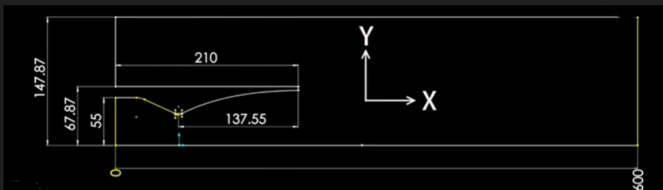

Fig. 6.1

Domain extends to 600mm

Shock line will appear at y=70mm

Rocket engine length=210mm

This is the geometry imported in space claim:



Fig. 6.2

By performing the face meshing across all the faces:

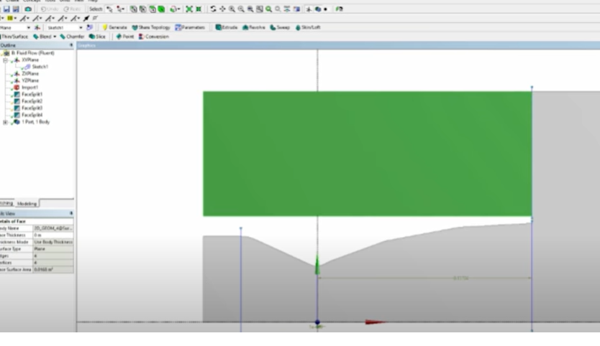

Fig. 6.3

And the parameters used for face meshing are:

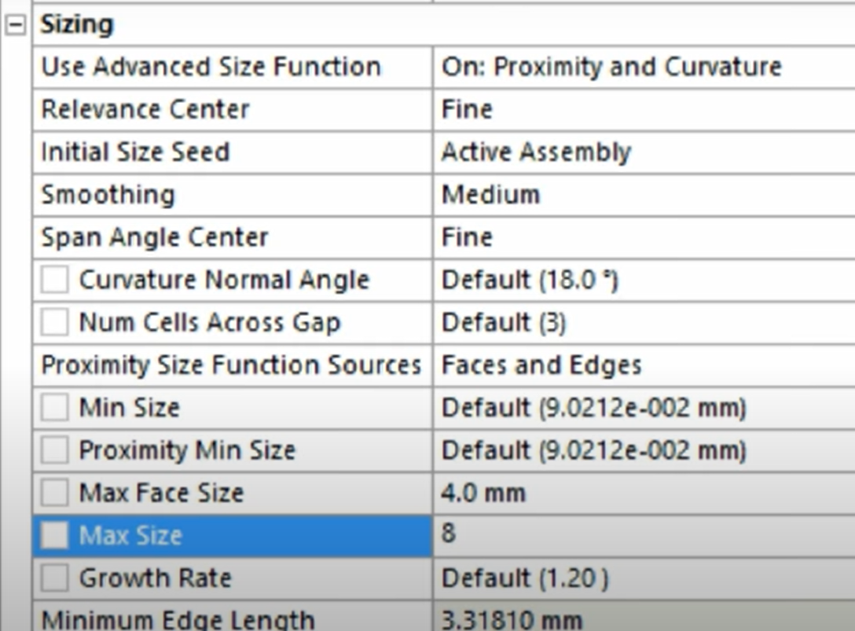

Fig. 6.4

Now the meshing is done across all the faces:

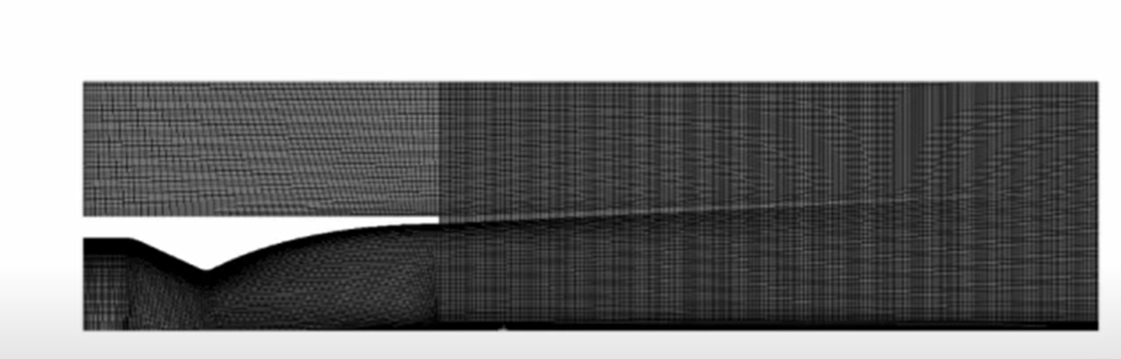

Fig. 6.5

Now the name selection is used where the inlet,outlet and walls are given names:

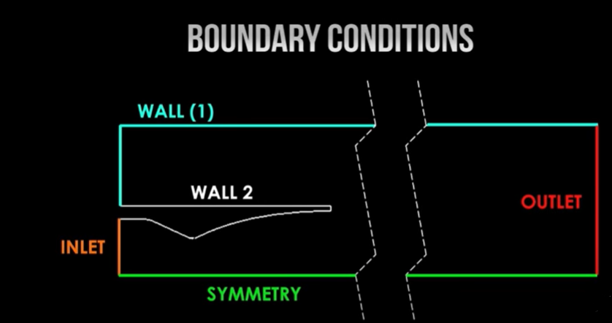

Fig. 6.6

SETUP: Now parallel processor is used with 2 solvers:

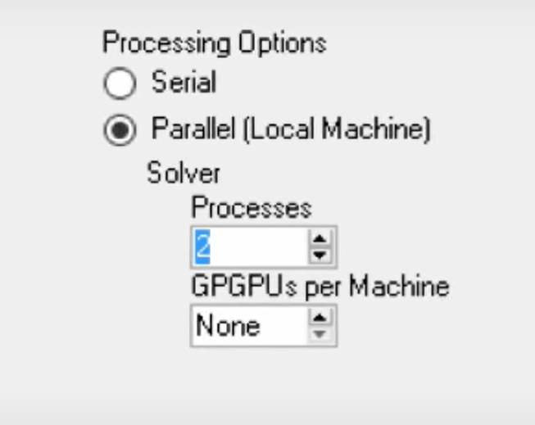

Fig 6.7

GENERAL MODEL:

Solver:

| Type | Density based |
| --- | --- |
| Velocity Formulation | Absolute |
| Time | Steady |
| 2D Space | Axisymmetric |

MODEL:

Turn the energy equation **ON** and **K-epsilon(2-eqn).**

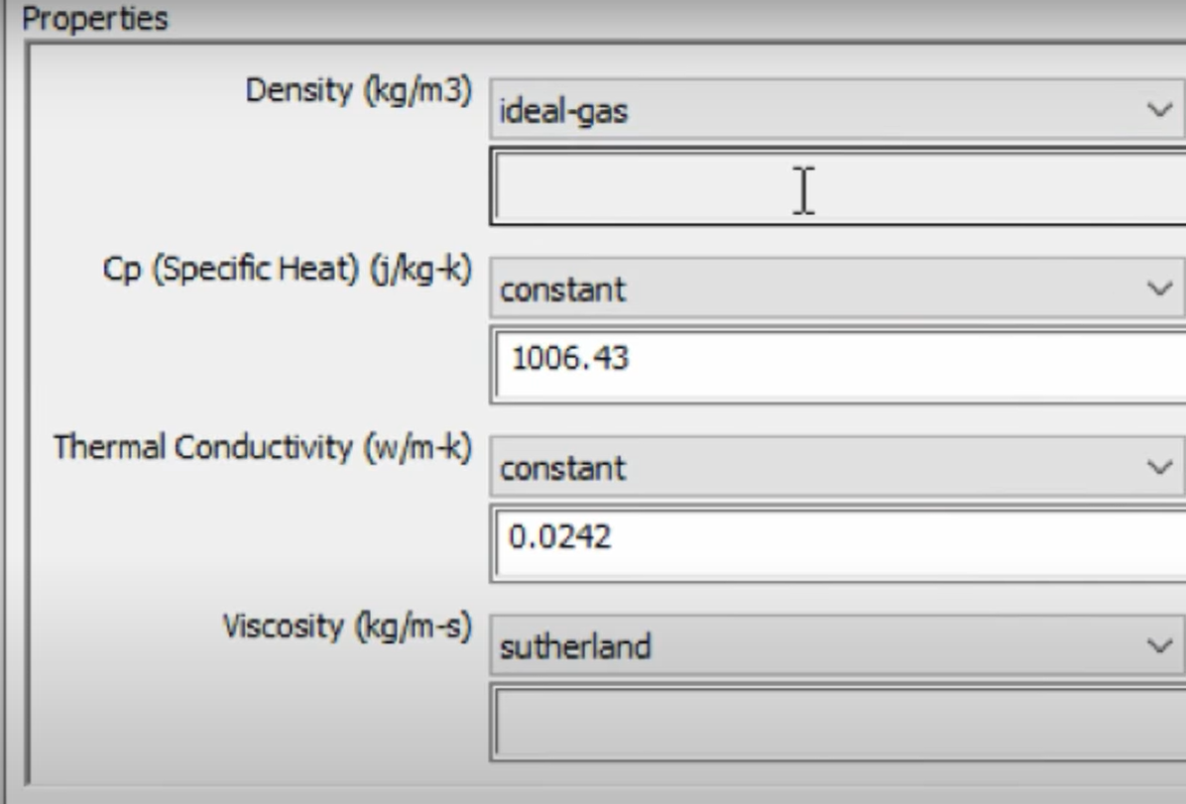

Fig. 6.8

Now giving gauge pressure and initial gauge pressure :

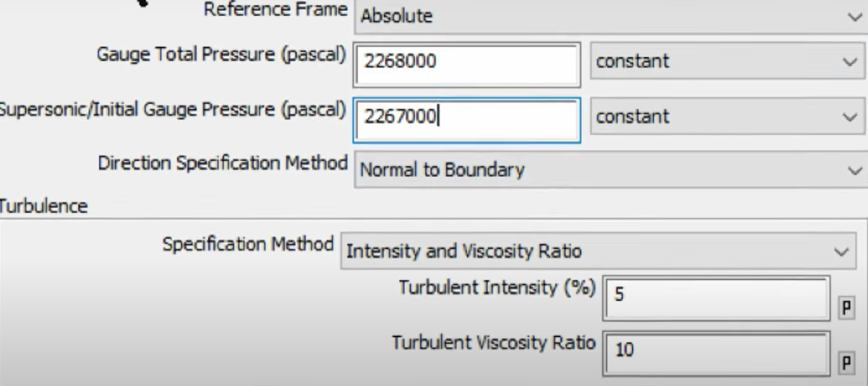

Fig. 6.9

And temperature is taken as 1200k at this gauge pressure:

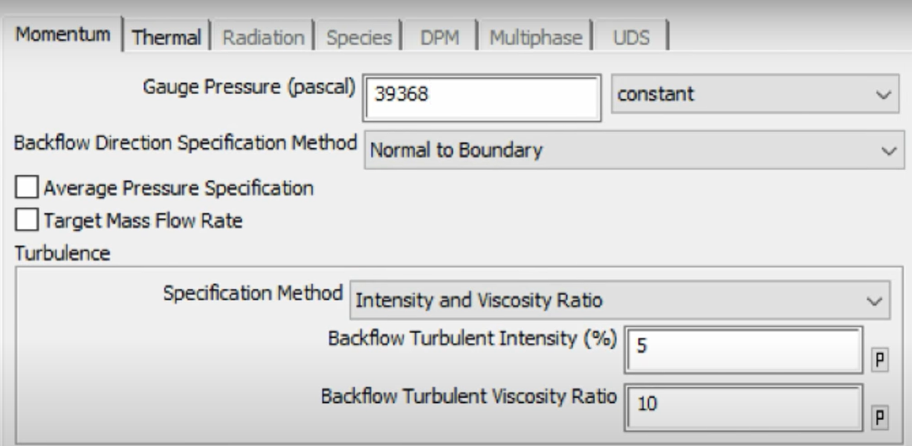

Fig. 6.10

Outlet temperature=243

Put operating pressure=0

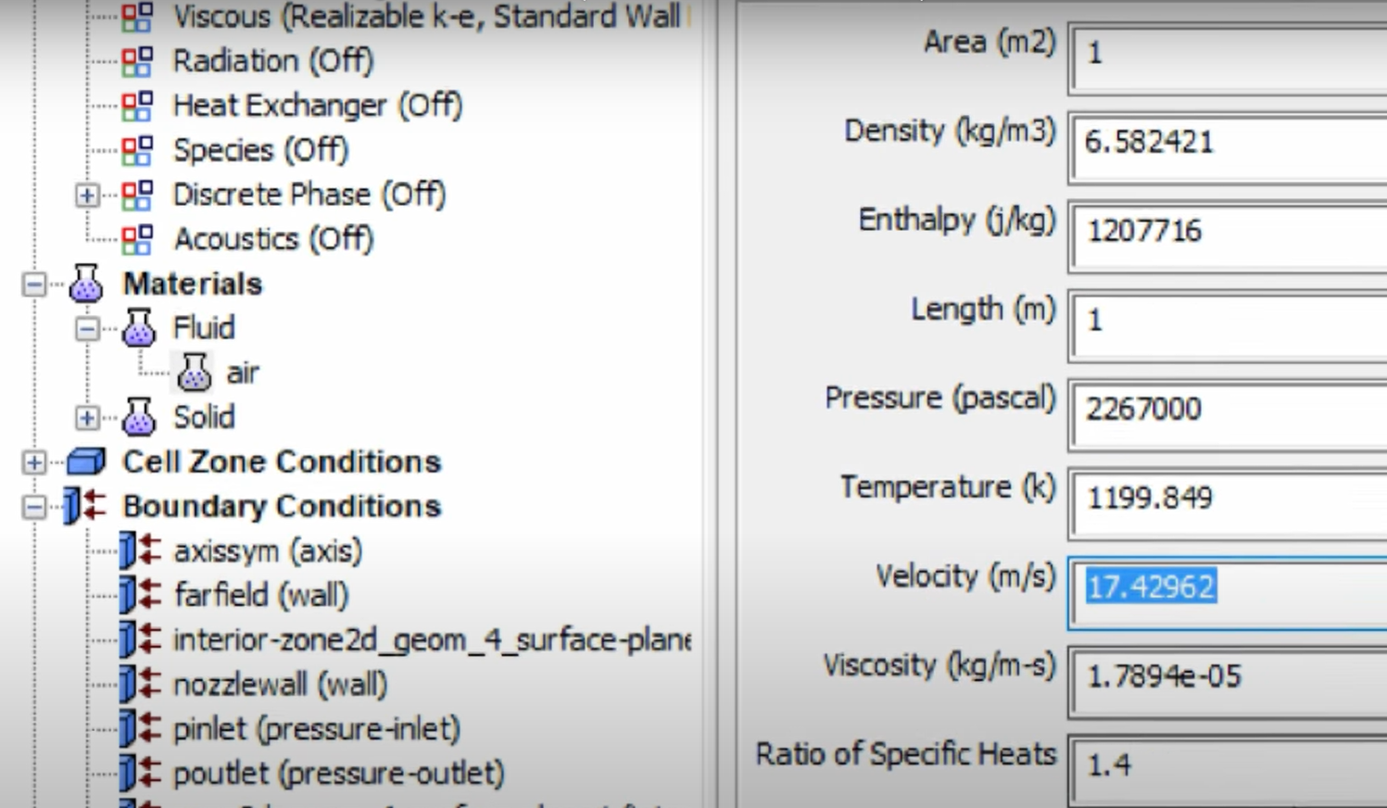

Fig. 6.11

Now performing the standard initialization at inlet before running the calculation with certain gauge pressure and axial velocity:

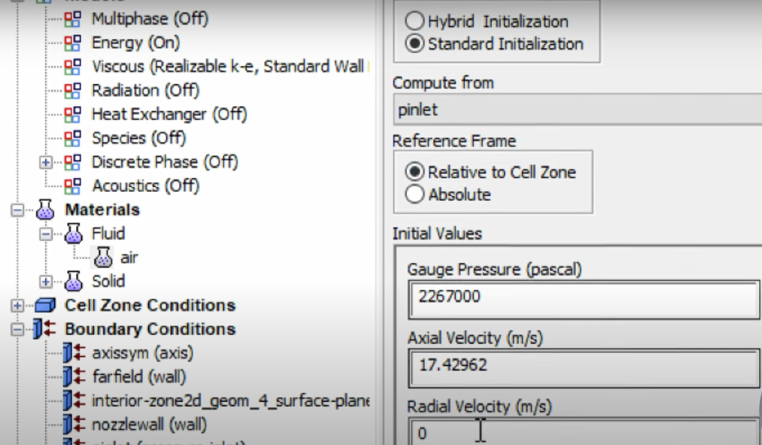

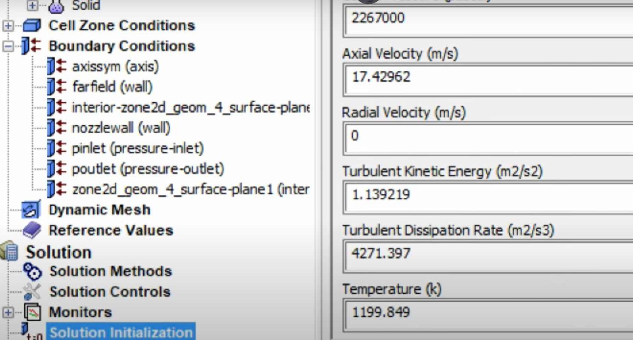

Fig. 6.12

Now run the calculation and give 2000 iterations.

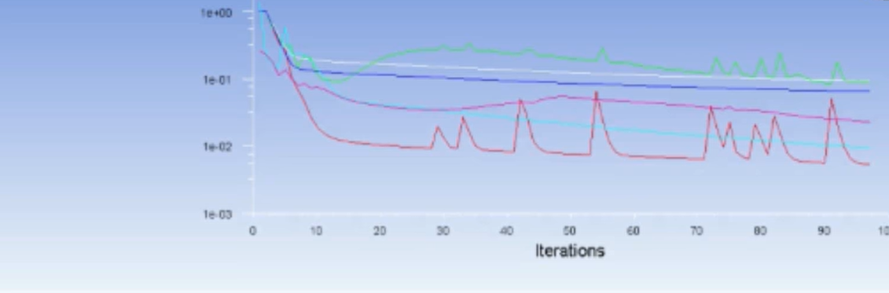

Fig. 6.13

Velocity - Mach Number Contour:

At Mach Number 2 the contour is as:

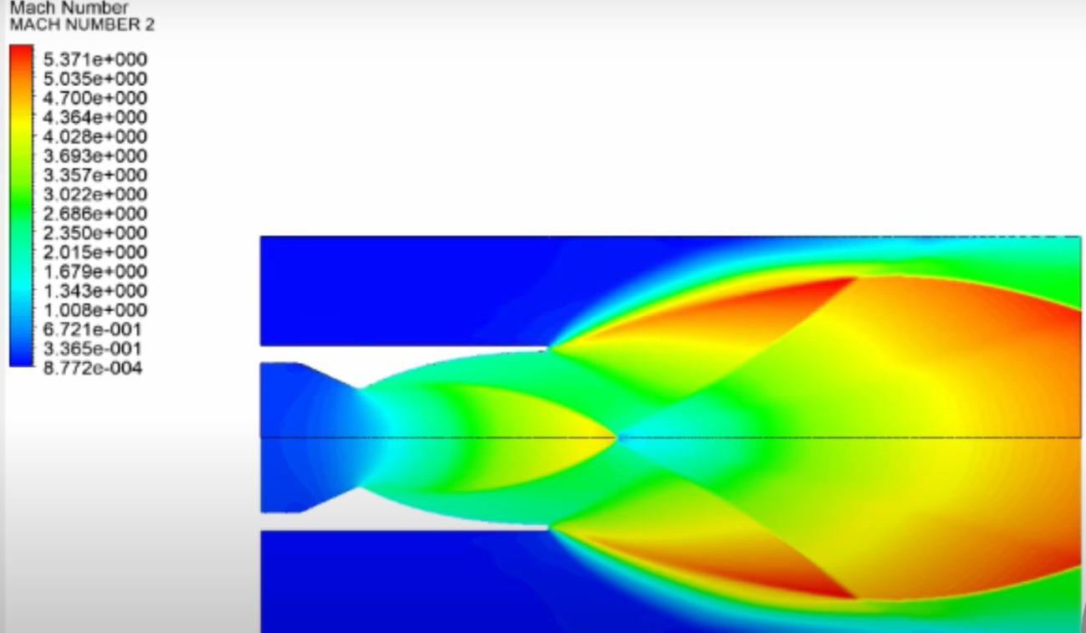

Fig. 6.14

And pressure contour is given as:

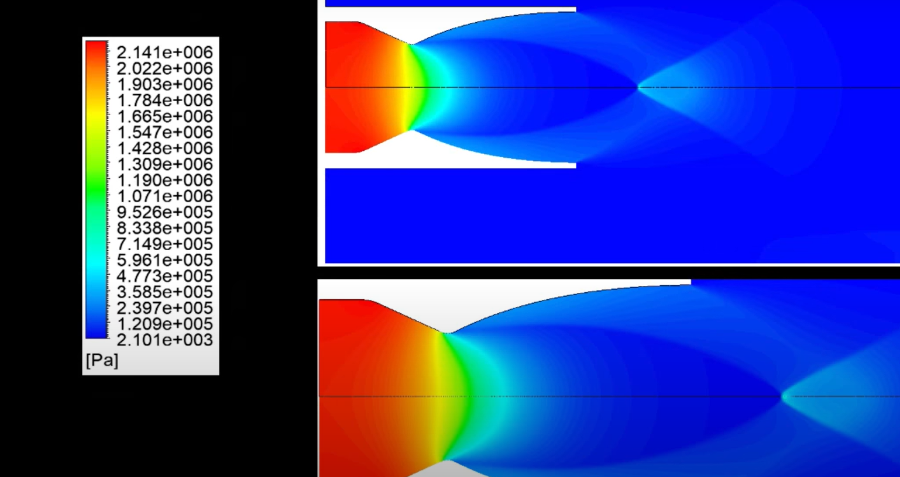

Fig. 6.15

**CHAPTER 7**

**FLOW ANALYSIS IN 3D NOZZLE**

Nozzle flow analysis in 3D flow involves studying the behavior of fluids passing through a nozzle in three dimensions. This analysis is crucial in various engineering applications, such as in aerospace, automotive, and manufacturing industries.

Here's a general outline of how nozzle flow analysis in 3D flow is typically conducted:

1. Problem Definition: Define the objectives of the analysis, including the desired performance parameters such as velocity distribution, pressure drop, and flow rate.
2. Geometry Creation: Create a detailed 3D model of the nozzle geometry using CAD (Computer-Aided Design) software. This model should accurately represent the physical dimensions and features of the nozzle, including its inlet and outlet sections, throat, and any geometric complexities.
3. Mesh Generation: Generate a computational mesh around the 3D geometry. The mesh should be fine enough to capture the flow features accurately while being computationally efficient. Mesh quality is critical for obtaining reliable results.
4. Boundary Conditions: Define the boundary conditions for the analysis, including the inlet velocity profile, pressure conditions at the inlet and outlet, and any other relevant boundary conditions such as temperature or turbulence parameters.
5. Solver Selection: Choose an appropriate computational fluid dynamics (CFD) solver for simulating the flow through the nozzle. Common solvers include finite volume or finite element methods. Ensure that the solver has capabilities for handling turbulent flows if applicable.
6. Numerical Simulation: Perform the numerical simulation of the flow using the selected solver and boundary conditions. This step involves solving the Navier-Stokes equations or their simplified forms to obtain the velocity, pressure, and other flow parameters throughout the domain.
7. Post-Processing: Analyze the simulation results to extract relevant information such as velocity profiles, pressure distributions, and flow patterns inside the nozzle. Visualization tools are often used to interpret and present the results effectively.
8. Validation and Optimization: Validate the simulation results by comparing them with experimental data or analytical solutions if available. Iterate on the analysis to optimize the nozzle design or operating conditions for improved performance.
9. Sensitivity Analysis: Conduct sensitivity analysis to evaluate the effects of uncertainties or variations in input parameters on the nozzle flow characteristics. This helps in understanding the robustness of the design or predicting its performance under different operating conditions.
10. Documentation and Reporting: Document the analysis methodology, results, and conclusions in a comprehensive report. Communicate the findings to stakeholders or decision-makers for further action or refinement of the design.

Throughout the analysis process, it's essential to consider factors such as fluid properties, boundary effects, turbulence modeling, and numerical convergence to ensure the accuracy and reliability of the results. Additionally, computational resources and time constraints may influence the choice of modeling approaches and mesh resolutions.

So the ANSYS simulation of 3D nozzle are:

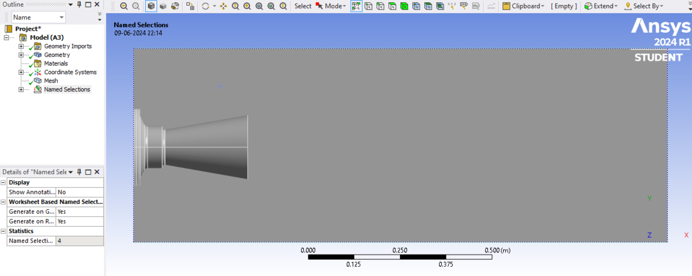

Fig. 7.2

And the triangular mesh obtained is:

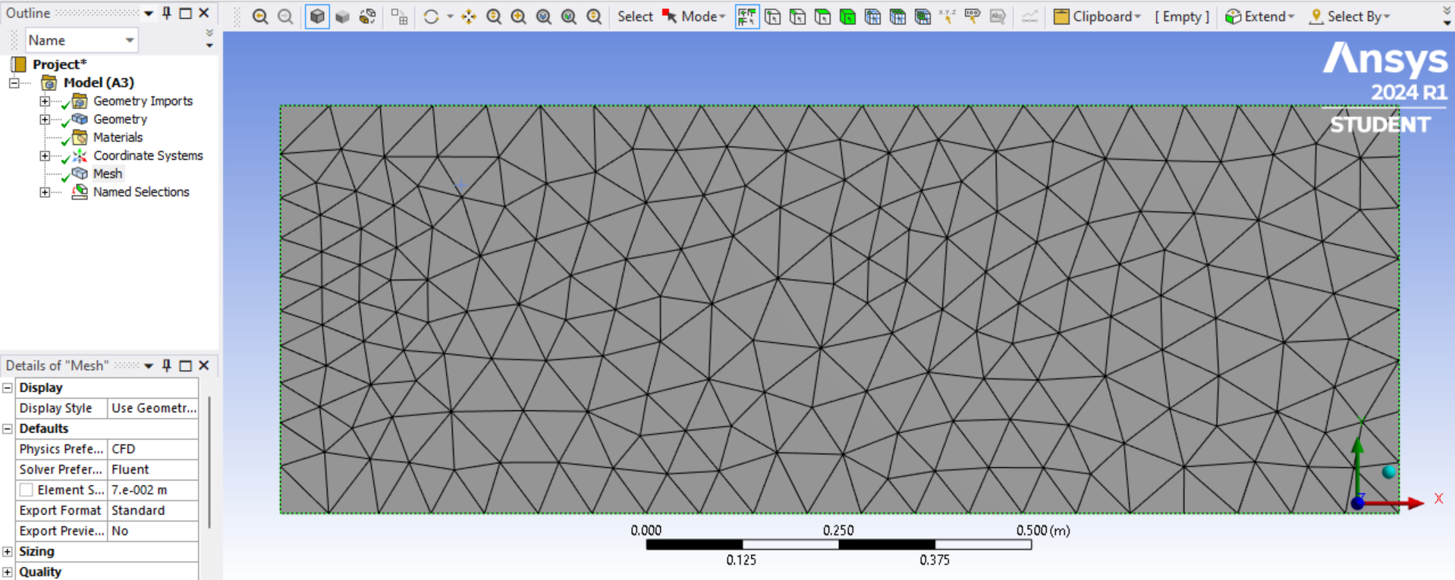

Fig. 7.3

Now selecting the parallel processor with one solver:

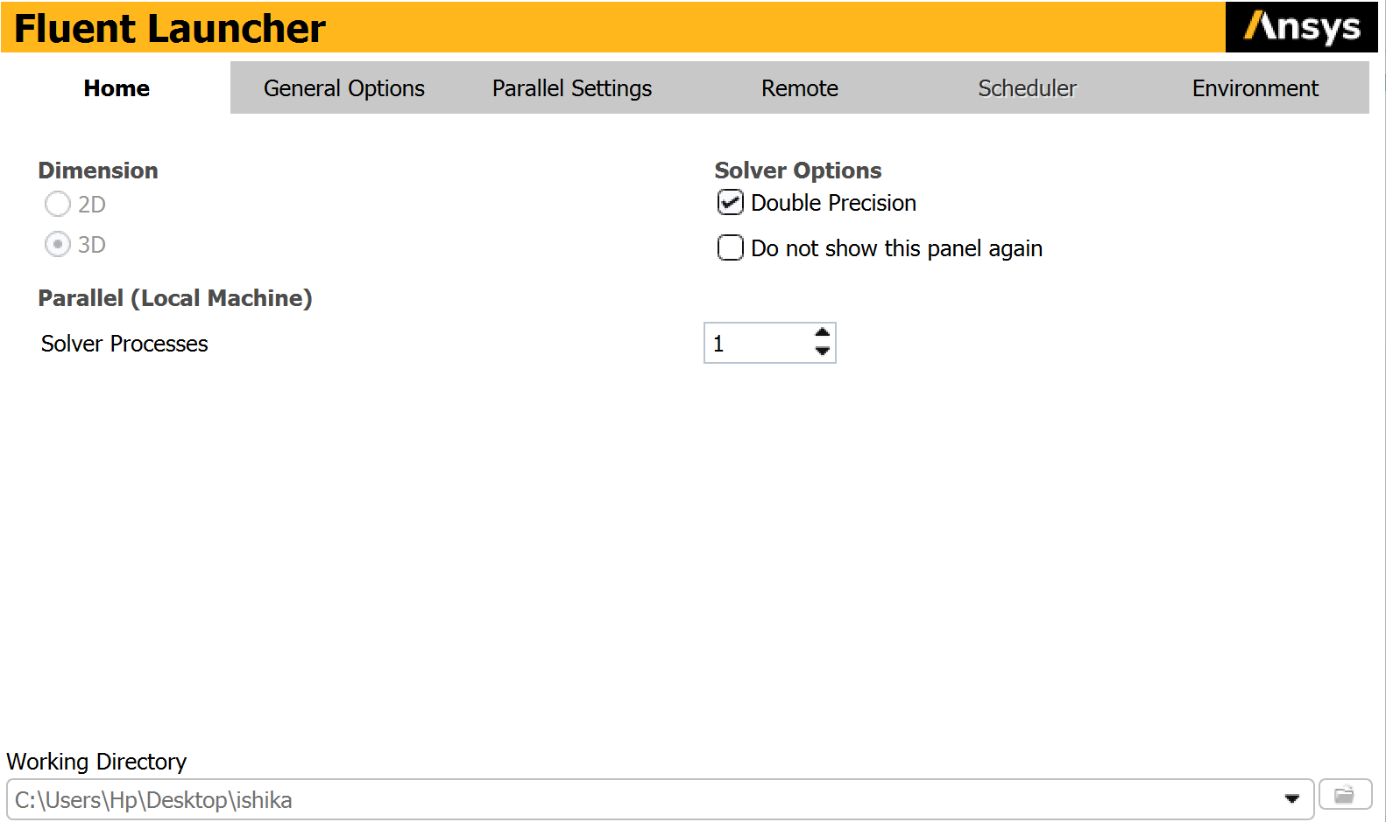

MODEL:

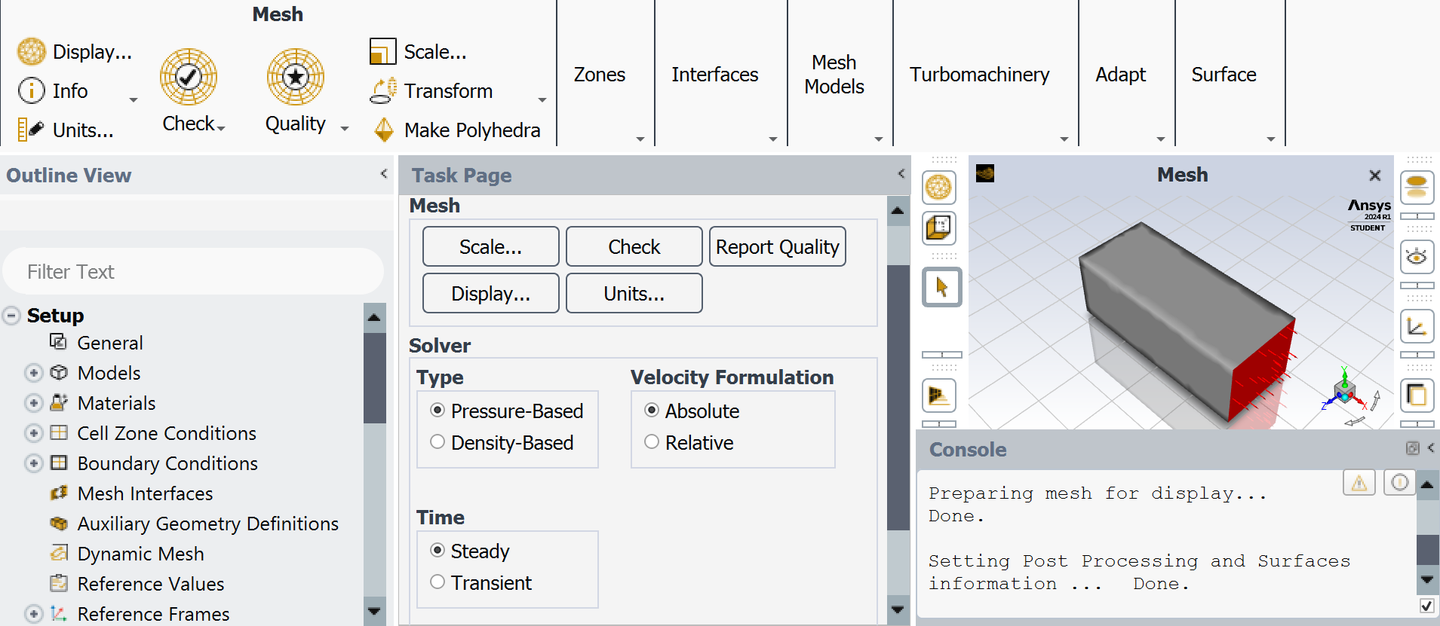

Fig. 7.5

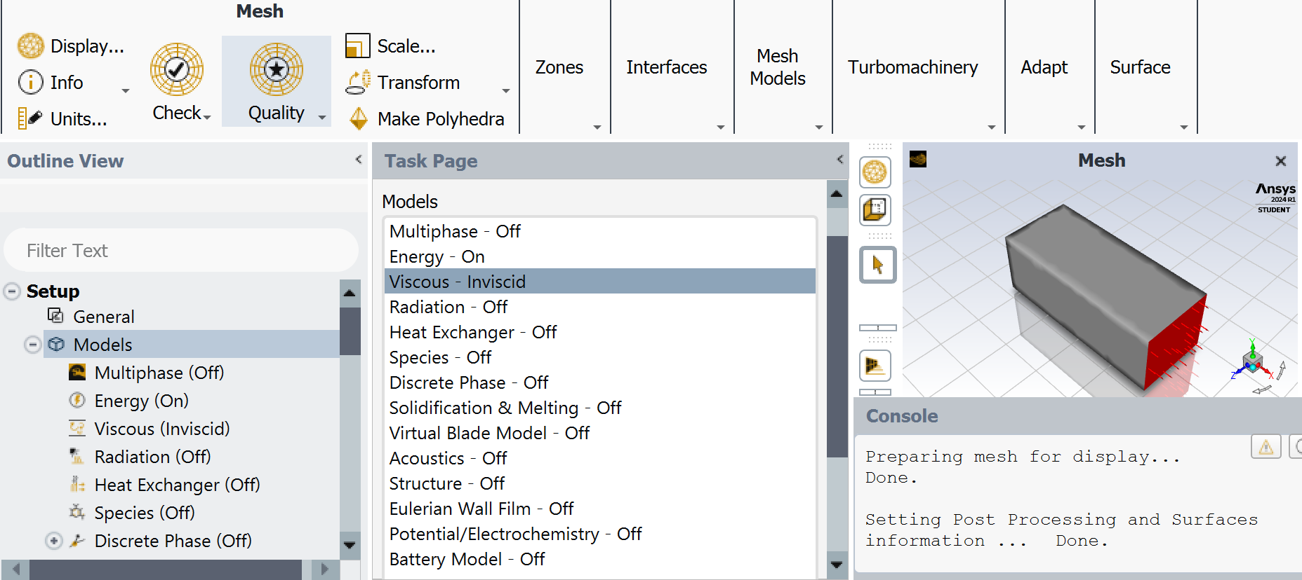

Fig. 7.6

Choosing the material as air with density as ideal gas and molecular weight as 20:

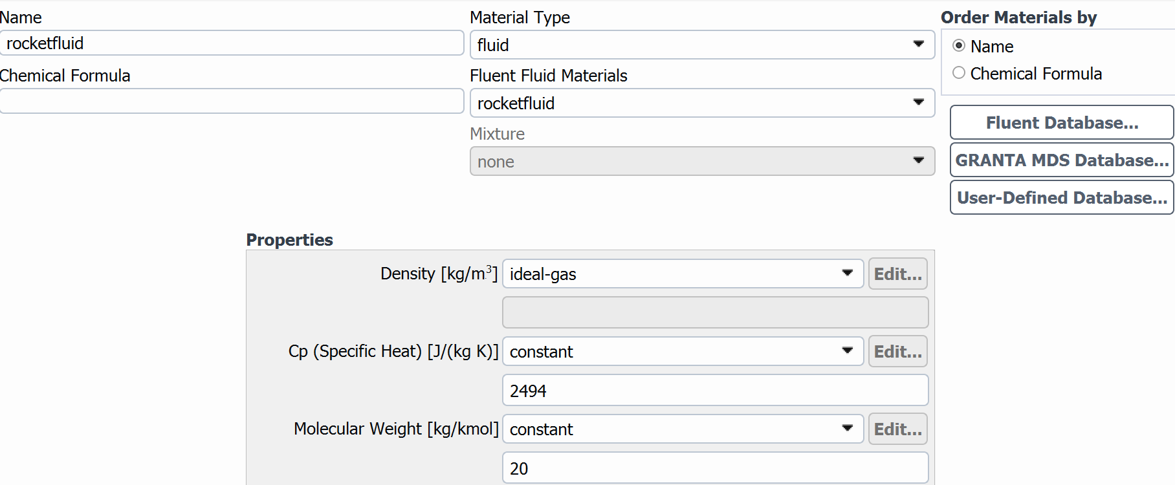

Fig. 7.7

Now choosing the inlet for giving conditions of pressure and temperature where temperature is taken as 3710k:

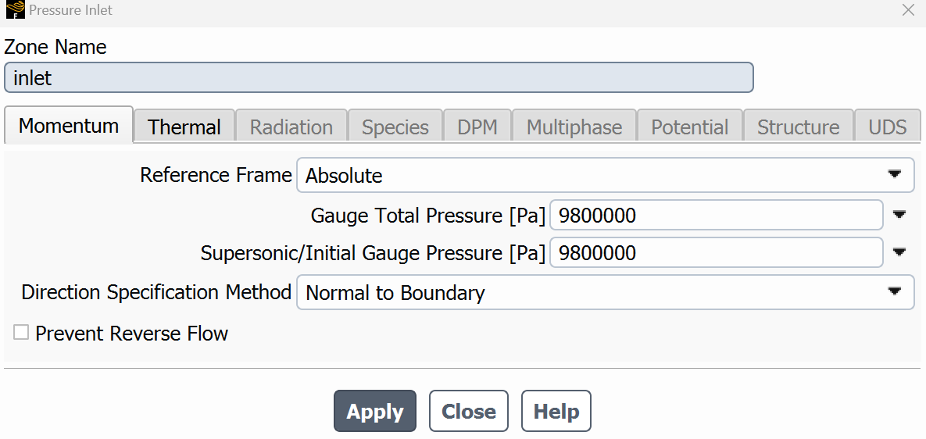

Fig. 7.8

So the reference values for the nozzle are:

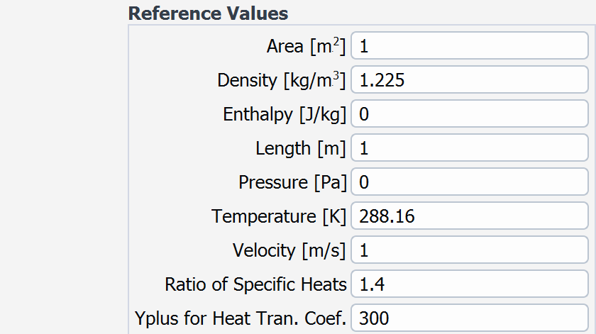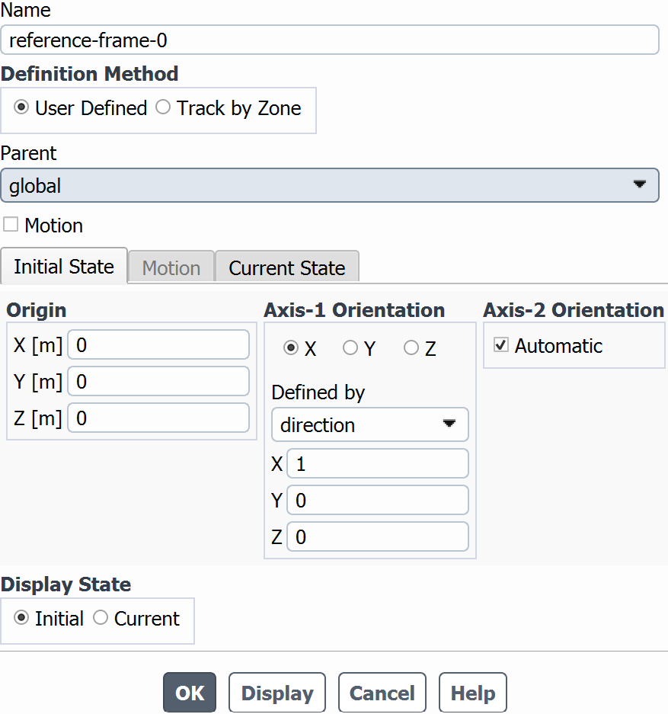

Fig. 7.9

Now putting the absolute criteria for x,y and z axis:

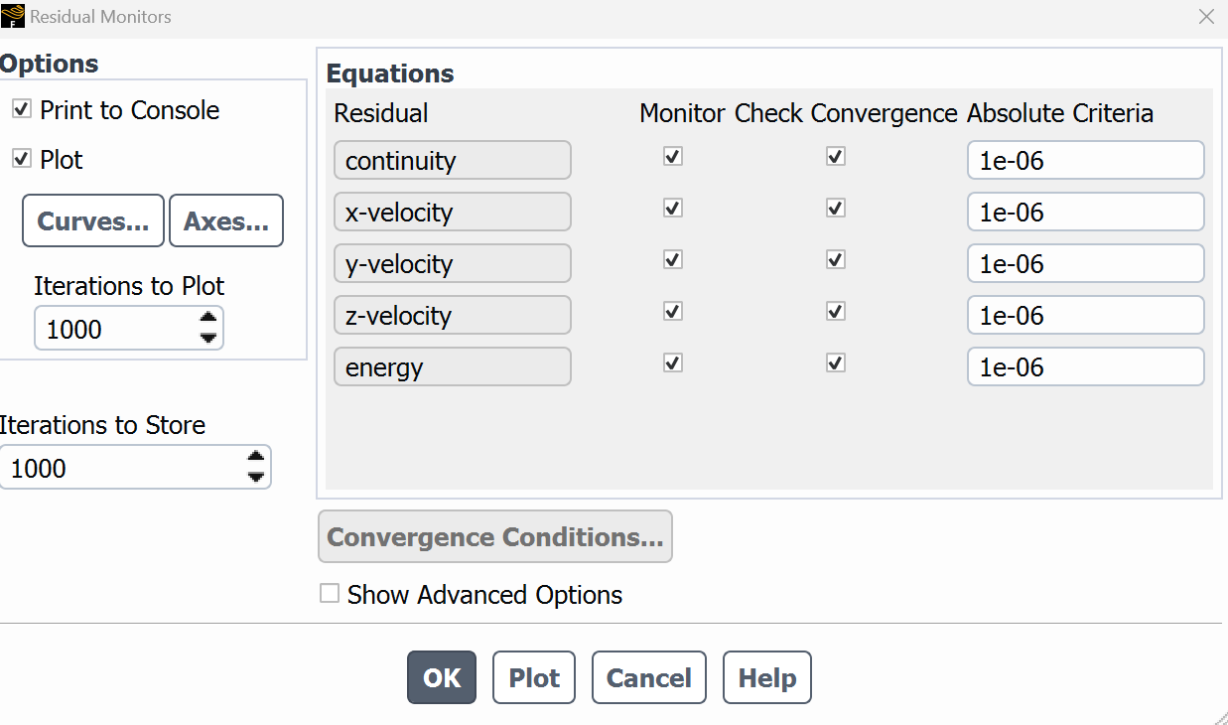

Fig. 7.10

And for initialization :

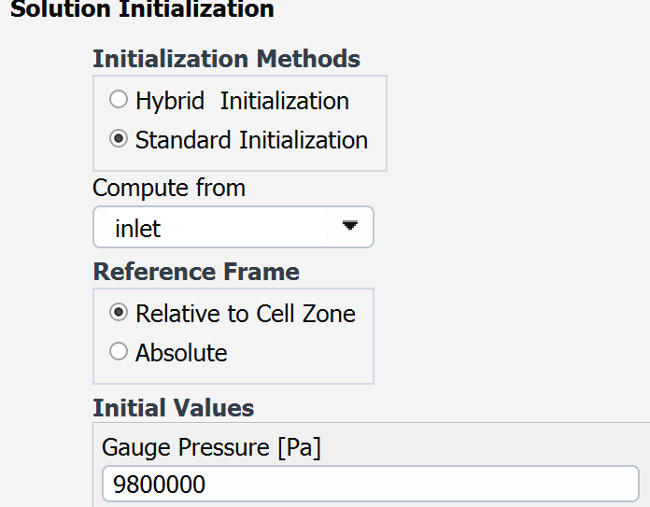

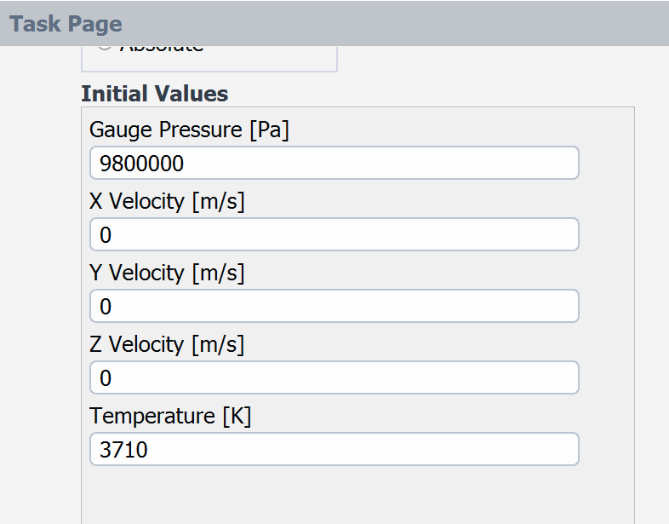

Fig. 7.11

And after that give number of iterations to be 1000, run the calculations:

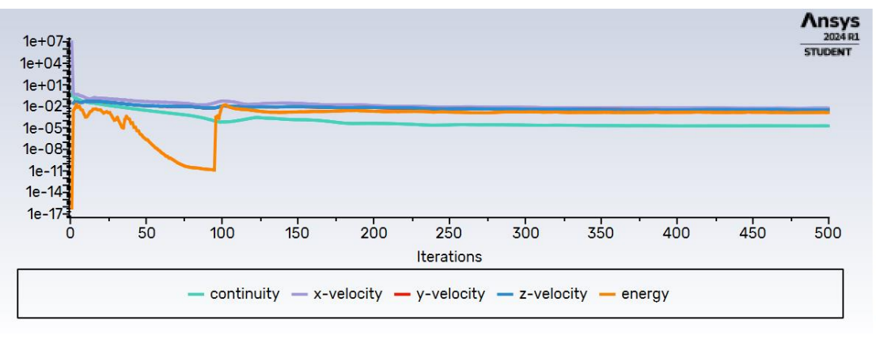

Fig. 7.12

Above converging graph is obtained from the calculations and then the results for density, pressure,temperature,velocity contours are given below:

Velocity contour:

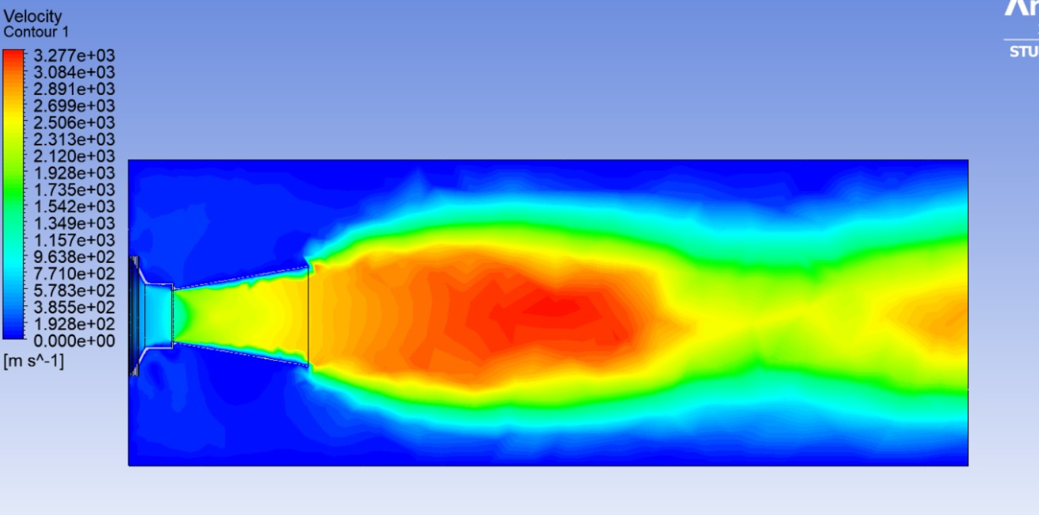

Fig. 7.13

Pressure contour:

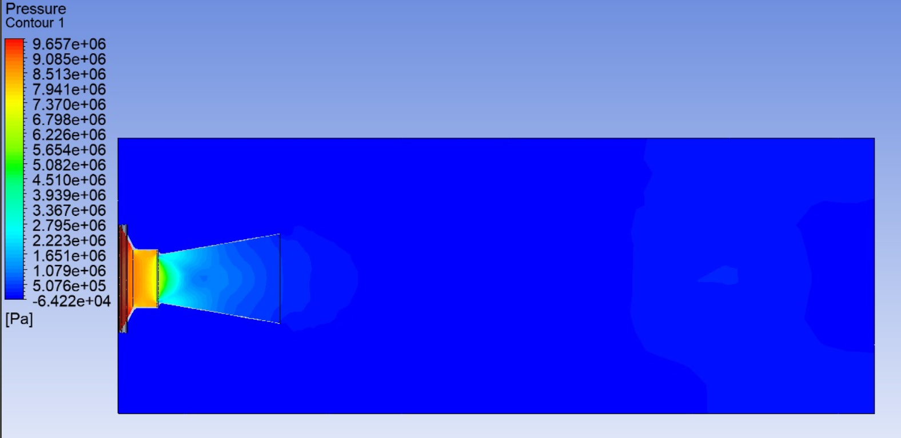

Fig. 7.14

Temperature contour:

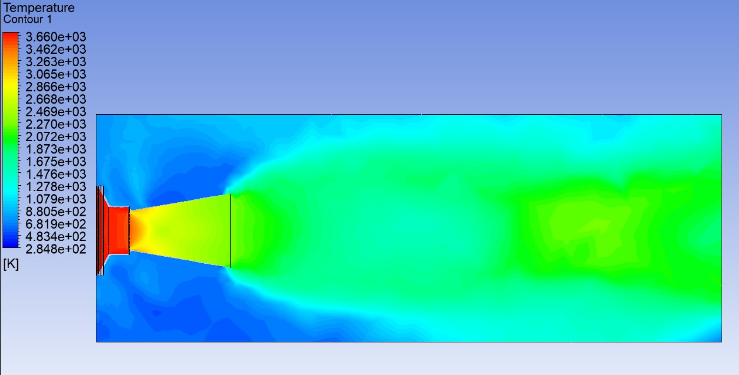

Fig. 7.15

Density contour:

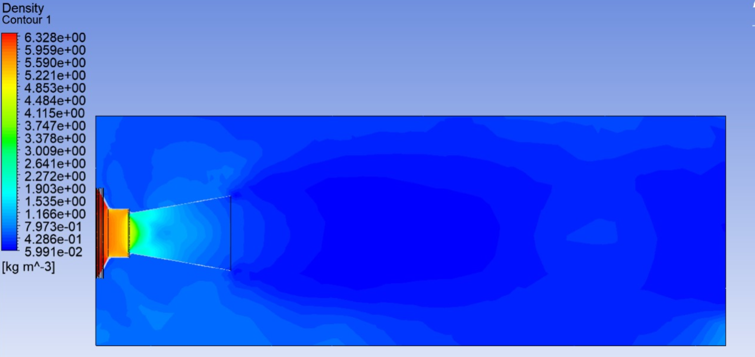

Fig. 7.16

And the velocity streamlines are given by:

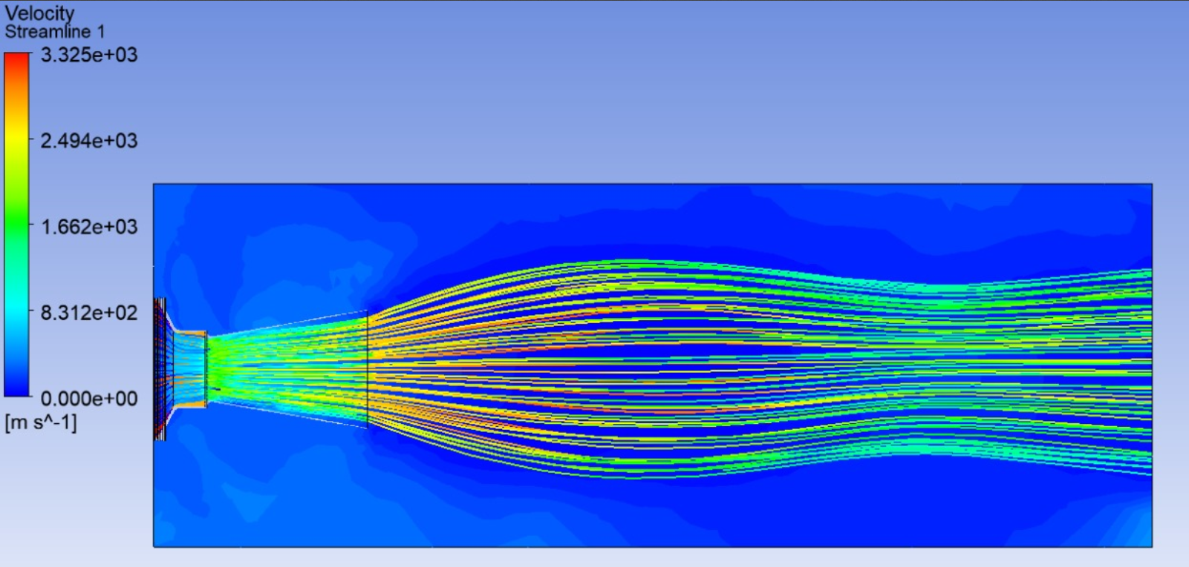

Fig. 7.17

**CHAPTER 8**

**MINIMIZING THE INTERFERENCE OF 3D NOZZLE FLOW**

Interference in rocket engines, particularly in the context of nozzles, can refer to several phenomena that affect performance. Here's a breakdown:

1. Flow Separation: Inefficient expansion of exhaust gases can occur if the flow separates from the nozzle walls before reaching the exit. This can happen due to adverse pressure gradients or inadequate expansion ratios. Flow separation leads to increased drag and decreased thrust efficiency.

2. Shock Waves: When the flow reaches supersonic speeds, shock waves can form within the nozzle. These shock waves can disrupt the flow and cause performance losses. Designing the nozzle to minimize shock wave formation is crucial for maintaining optimal performance.

3. Boundary Layer Effects: The boundary layer refers to the thin layer of fluid near the walls of the nozzle where viscous effects dominate. If the boundary layer thickens excessively, it can impede the flow and reduce efficiency. Boundary layer control techniques, such as boundary layer suction or passive measures like contour shaping, are used to mitigate these effects.

4. Flow Separation at the Throat: Flow separation can also occur at the throat of the nozzle, where the flow velocity is maximum. This can lead to reduced thrust and efficiency. Proper shaping of the nozzle and careful attention to design parameters can minimize this issue.

5. Secondary Flows: In complex nozzle geometries, secondary flows can develop, leading to non-uniformities in the flow field. These secondary flows can cause pressure losses and affect the overall performance of the engine.

To mitigate these interference effects, engineers employ advanced computational fluid dynamics (CFD) simulations, wind tunnel testing, and careful design optimization. Additionally, innovative nozzle designs, such as aerospike nozzles or multi-bell nozzles, aim to minimize interference effects and improve overall engine performance.

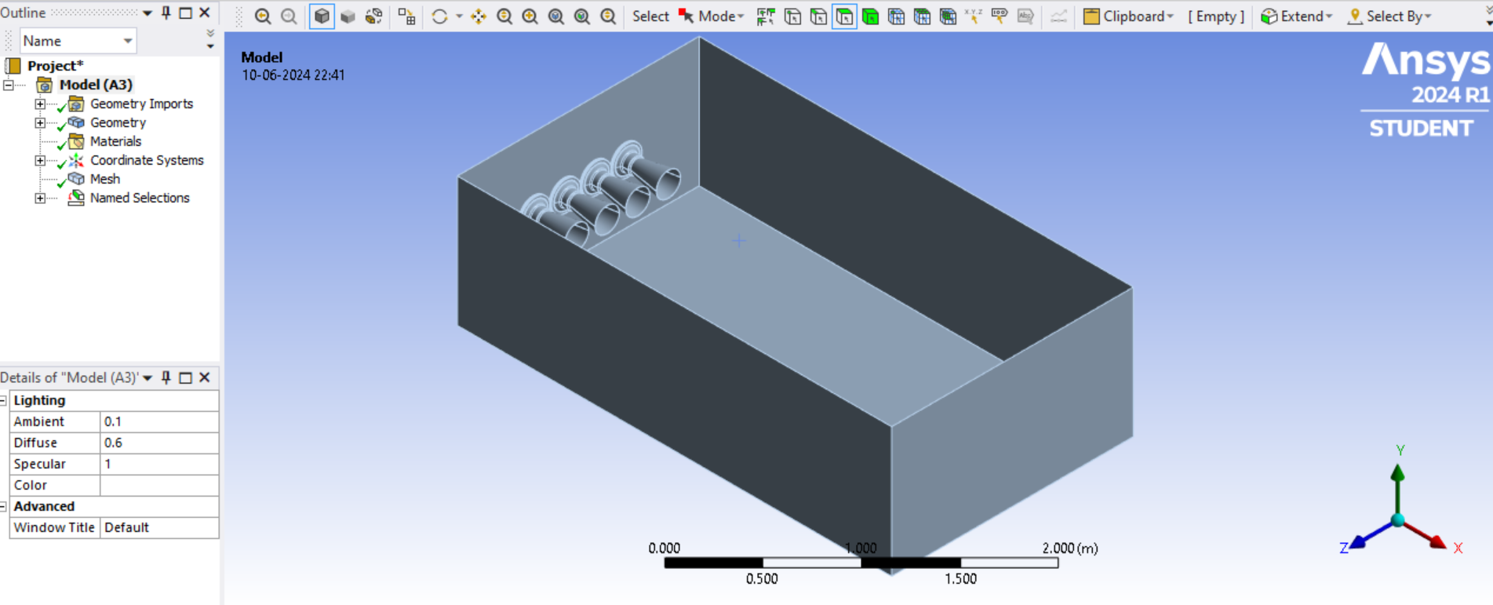

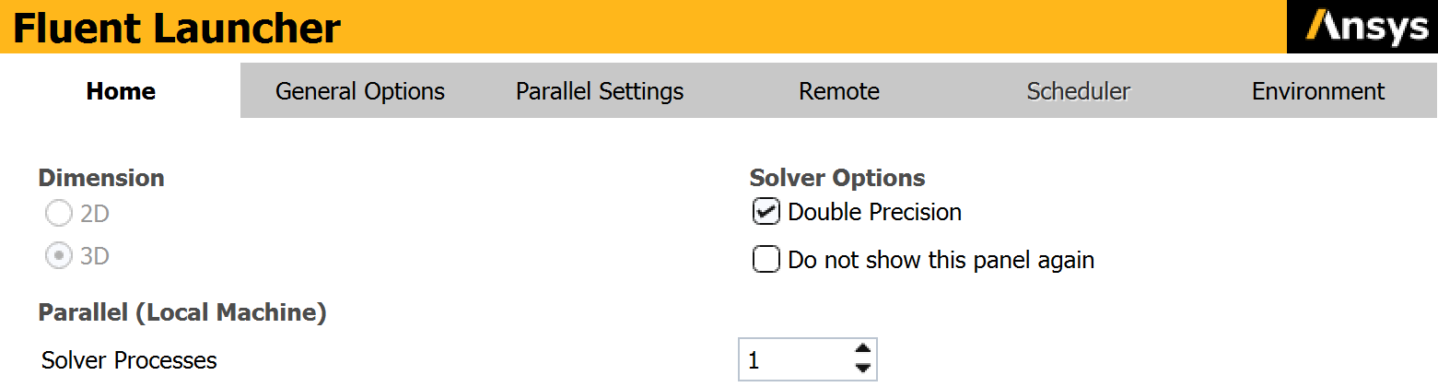

Solver type -Pressure based

Velocity formulation-Absolute

Time-Steady

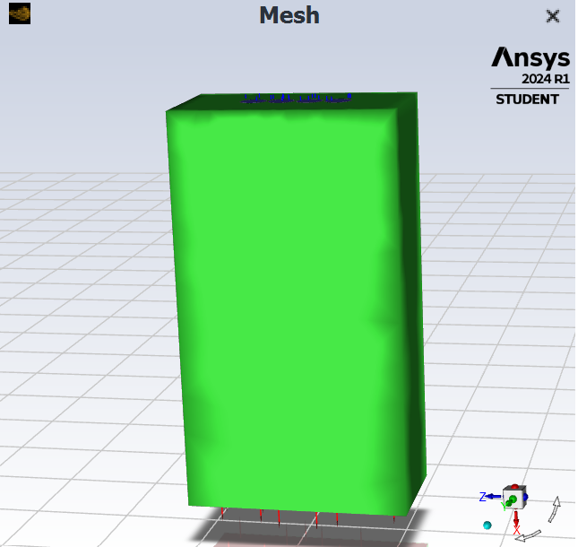

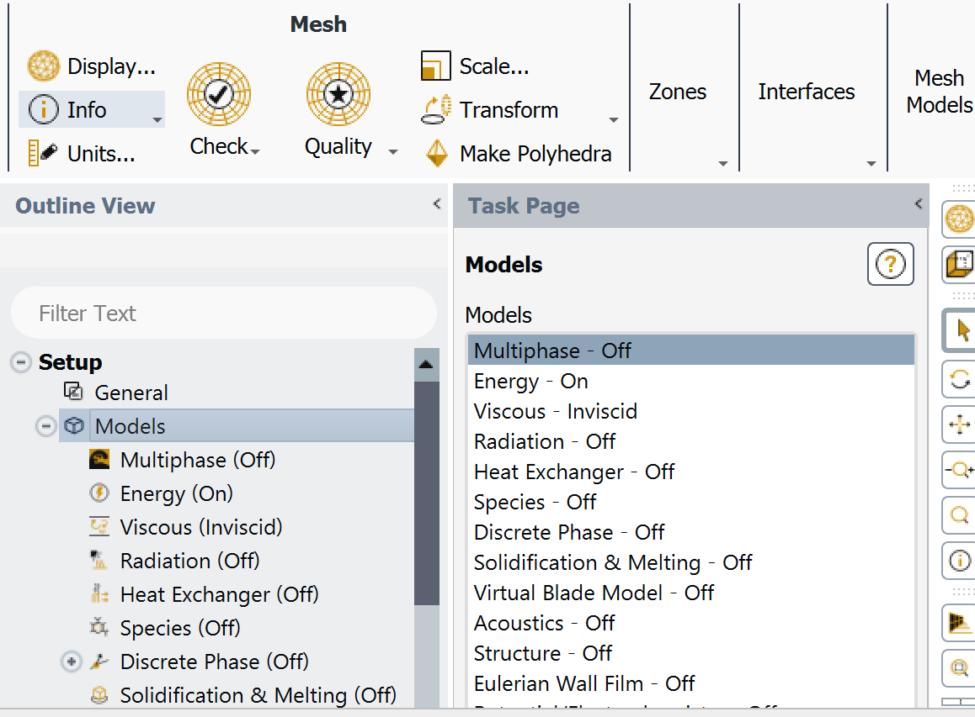

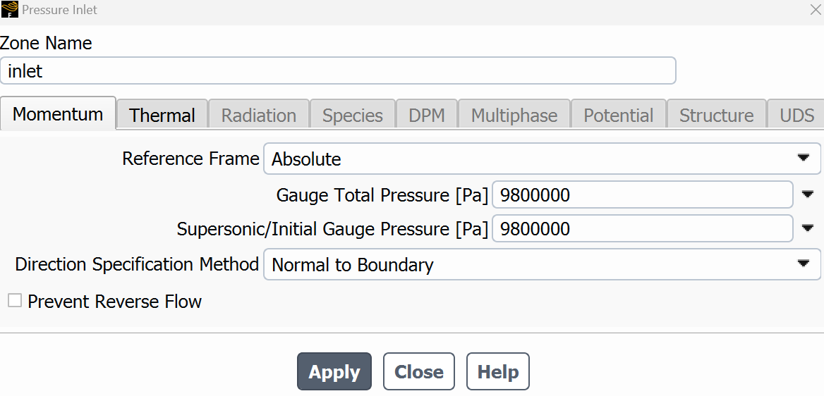

With temperature taken as 3710k.

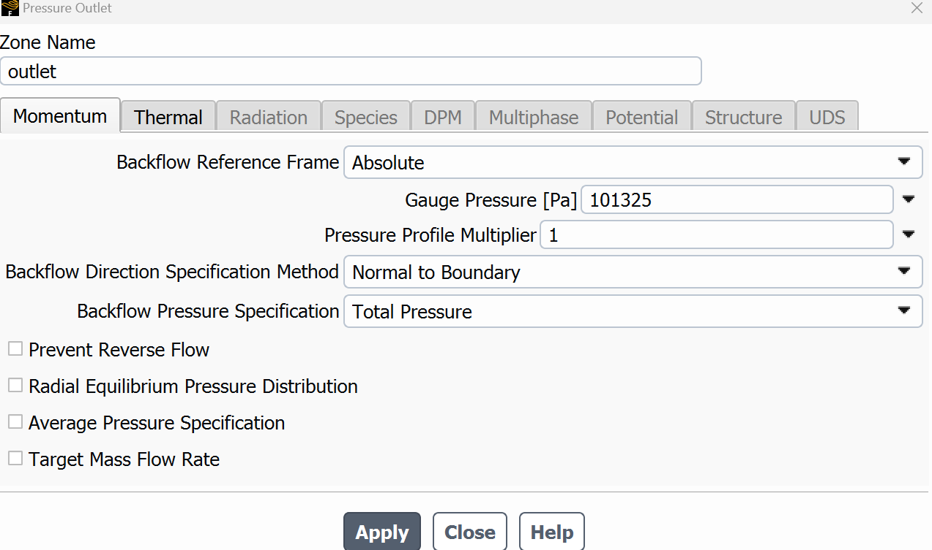

With backflow total temperature as 300k.

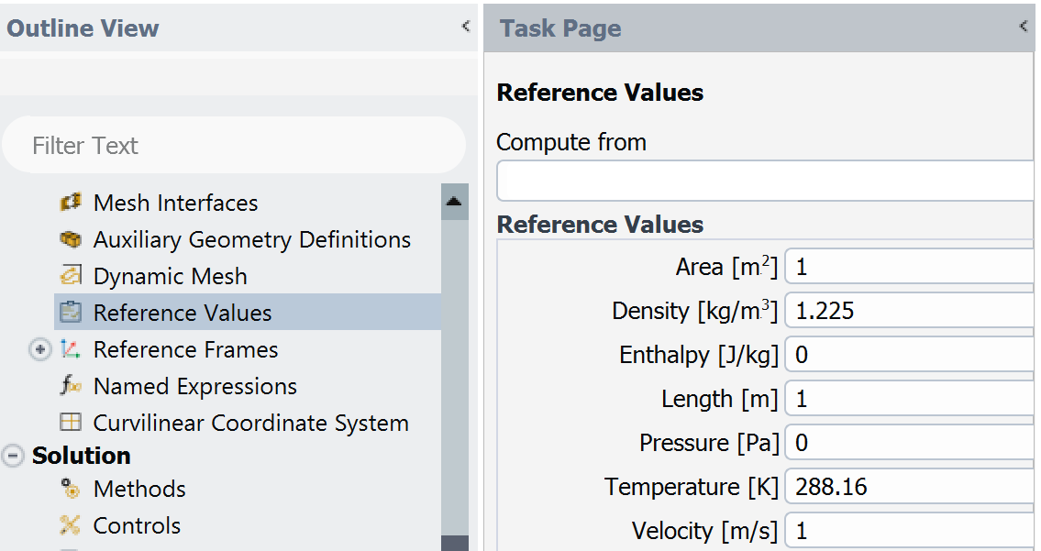

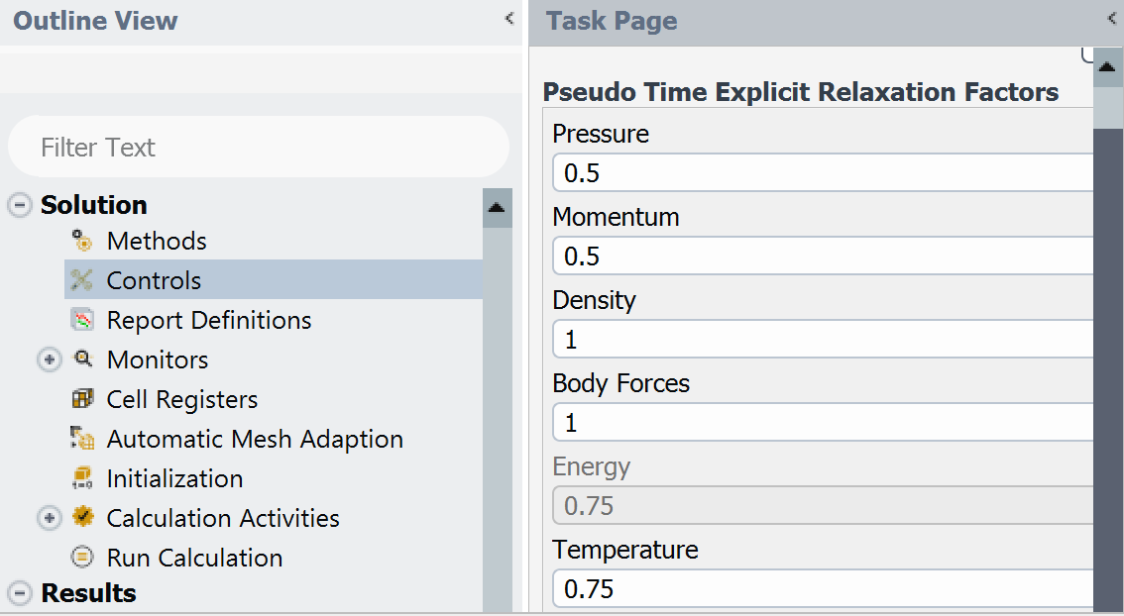

With standard initialization across inlet and reference frame relative to cell zone conditions the parameters are given as:

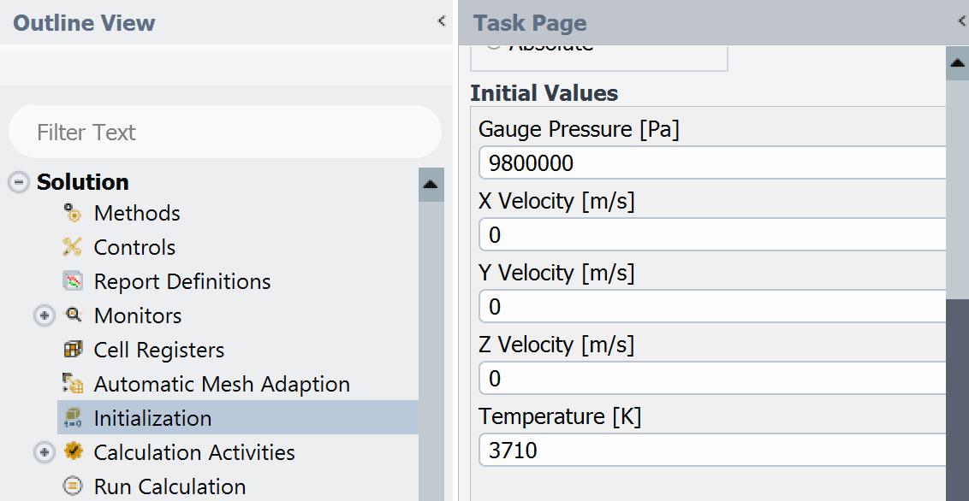

Now giving 500 iterations at reporting interval 1:

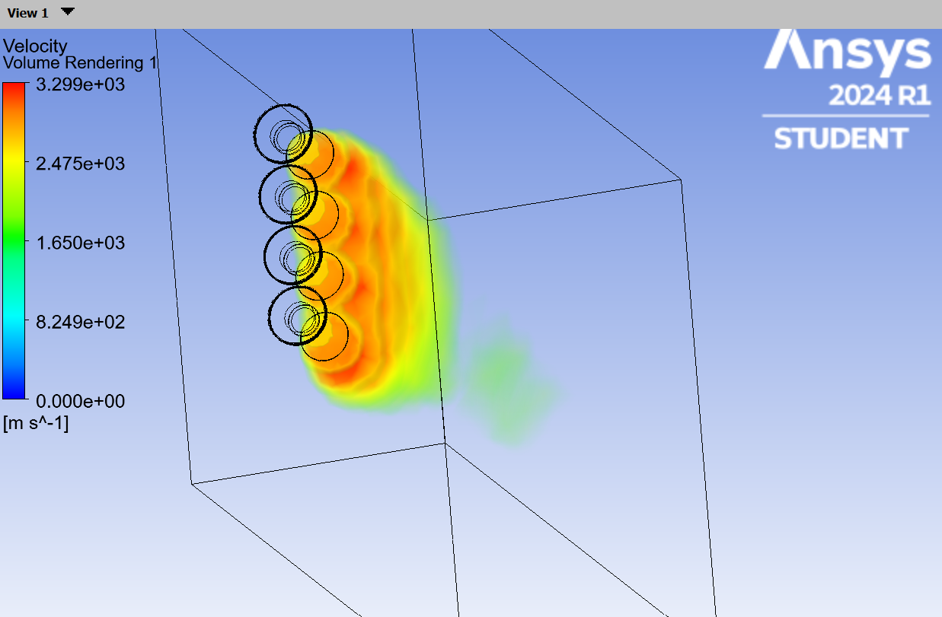

**SET UP 2**

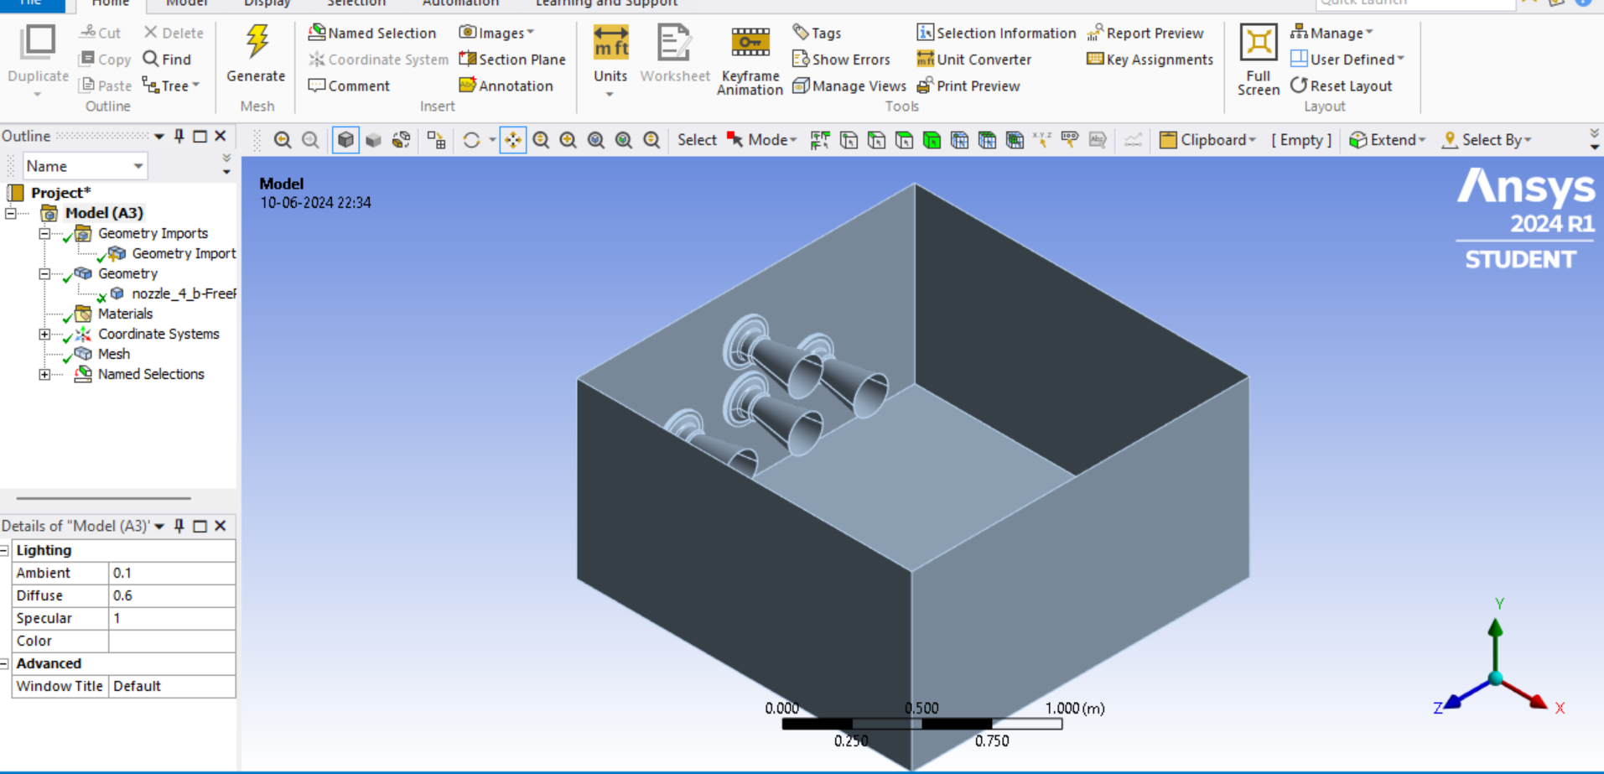

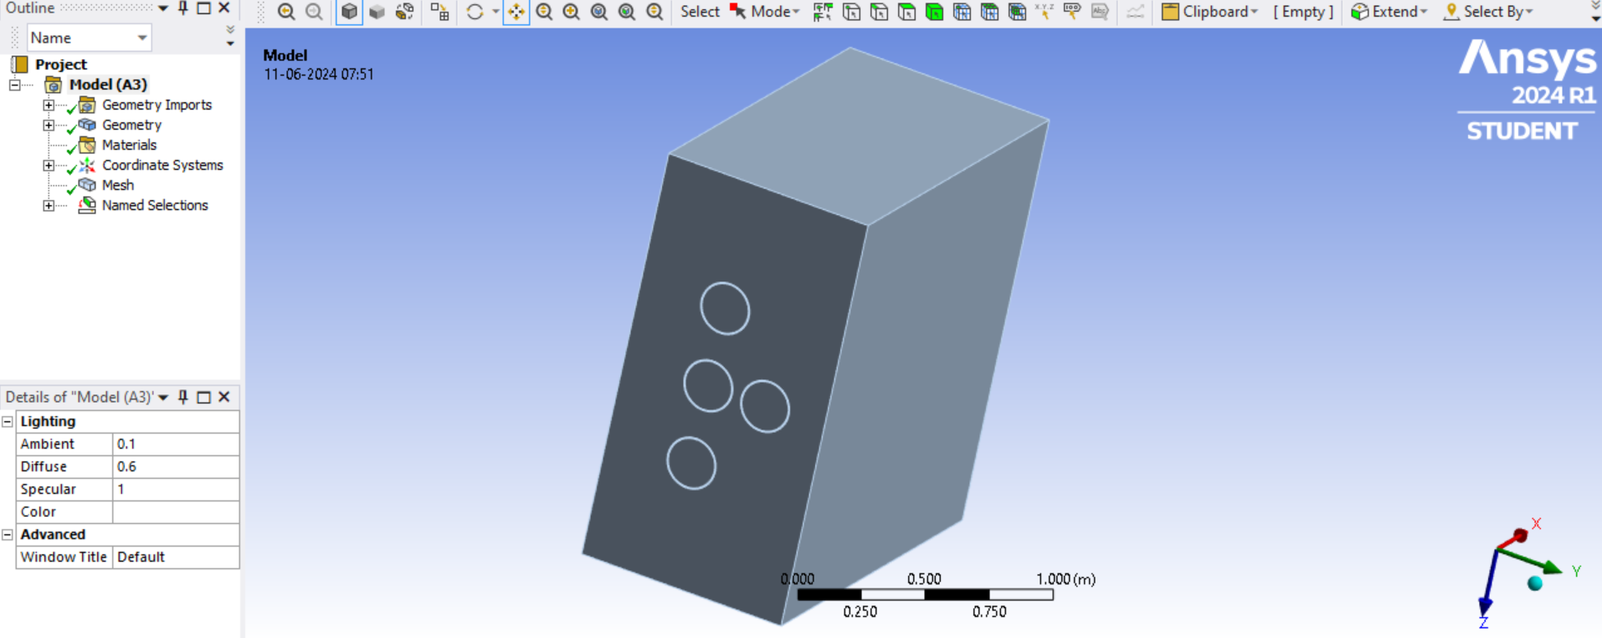

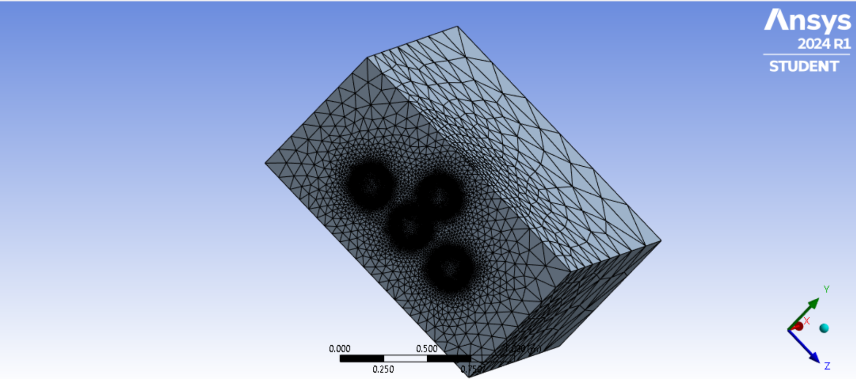

Now by naming the inlet,wall and outlet to the nozzle and domain move to setup.



Solver type -Pressure based

Velocity formulation-Absolute

Time-Steady

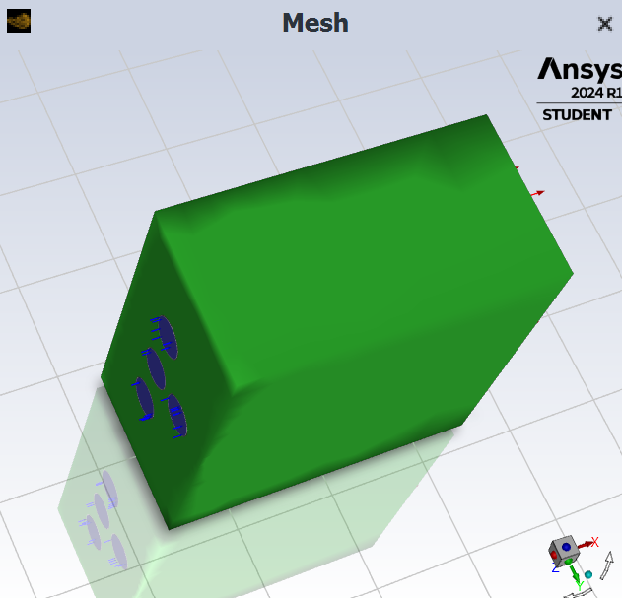

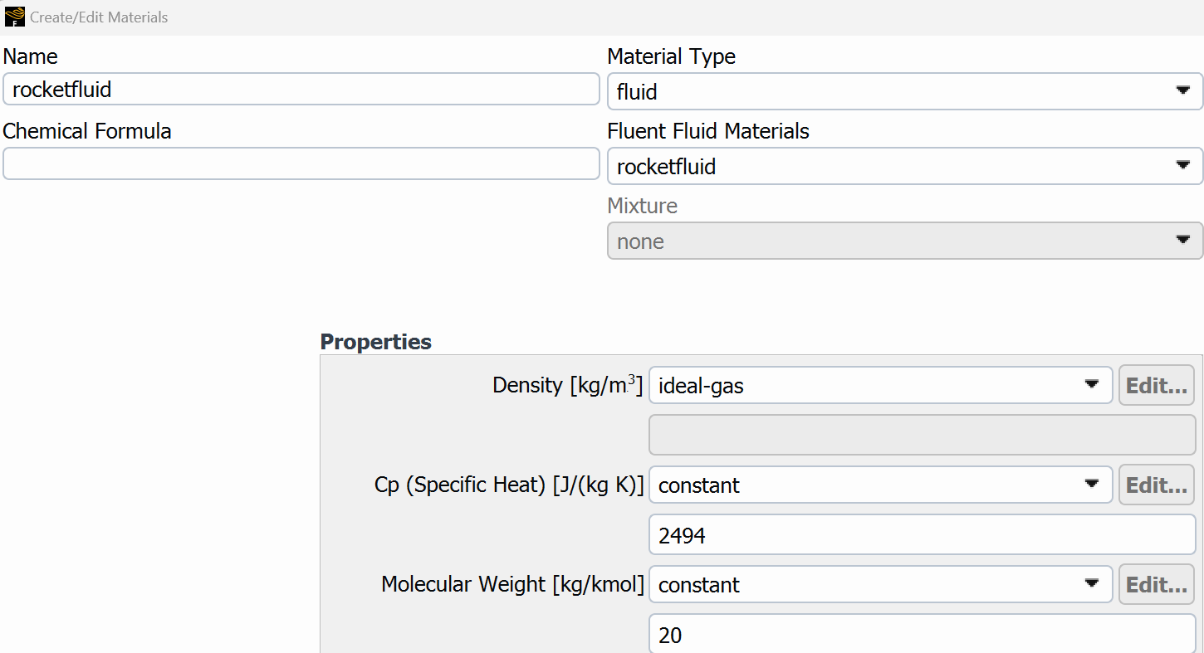



With temperature taken as 3710k.



With backflow total temperature as 300k.





With standard initialization across inlet and reference frame relative to cell zone conditions the parameters are given as:



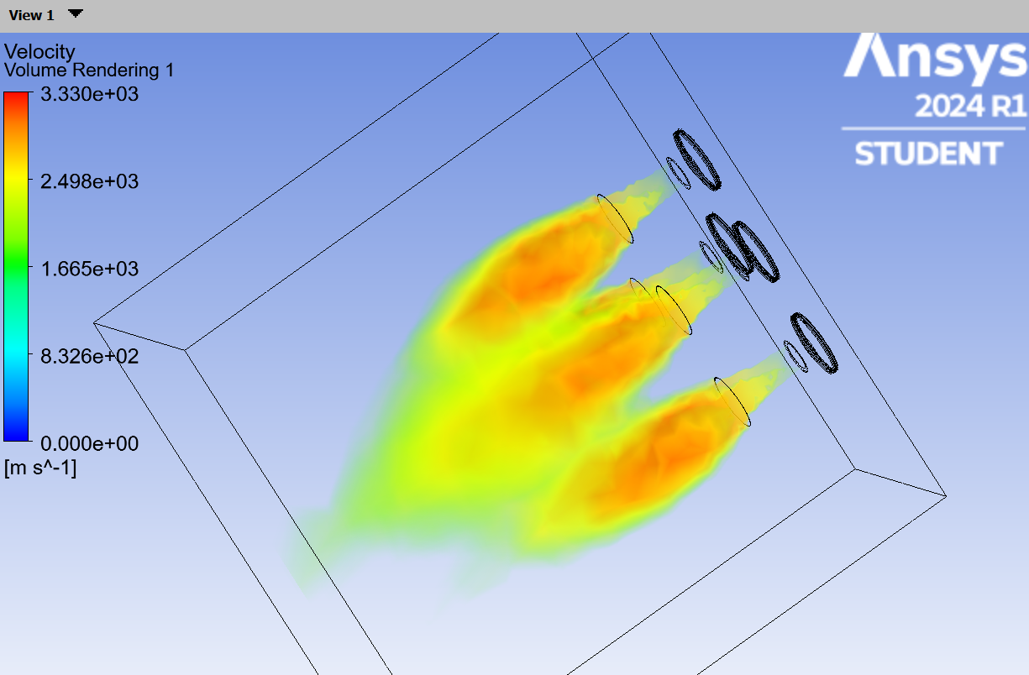

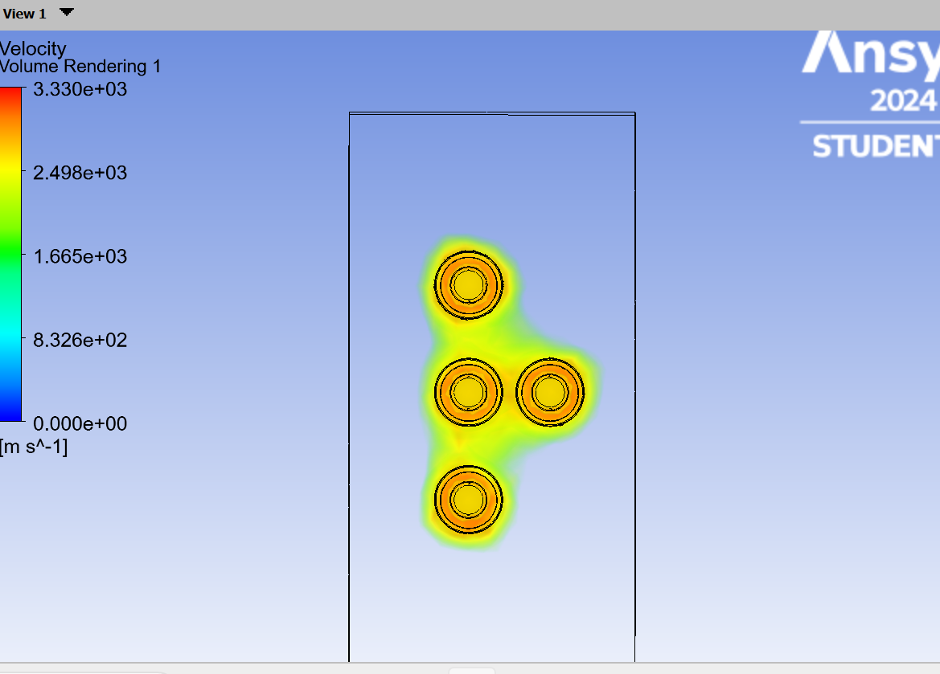

**SET UP 3**

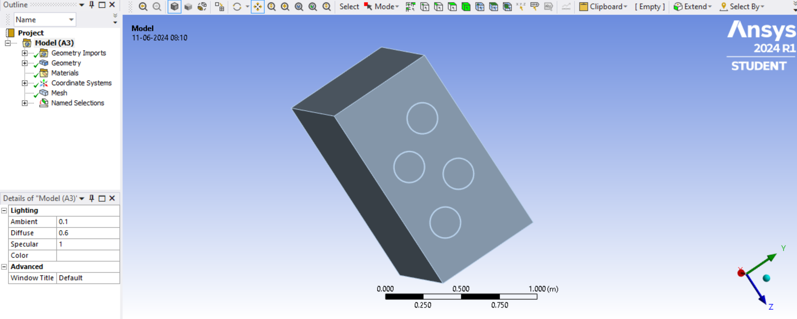

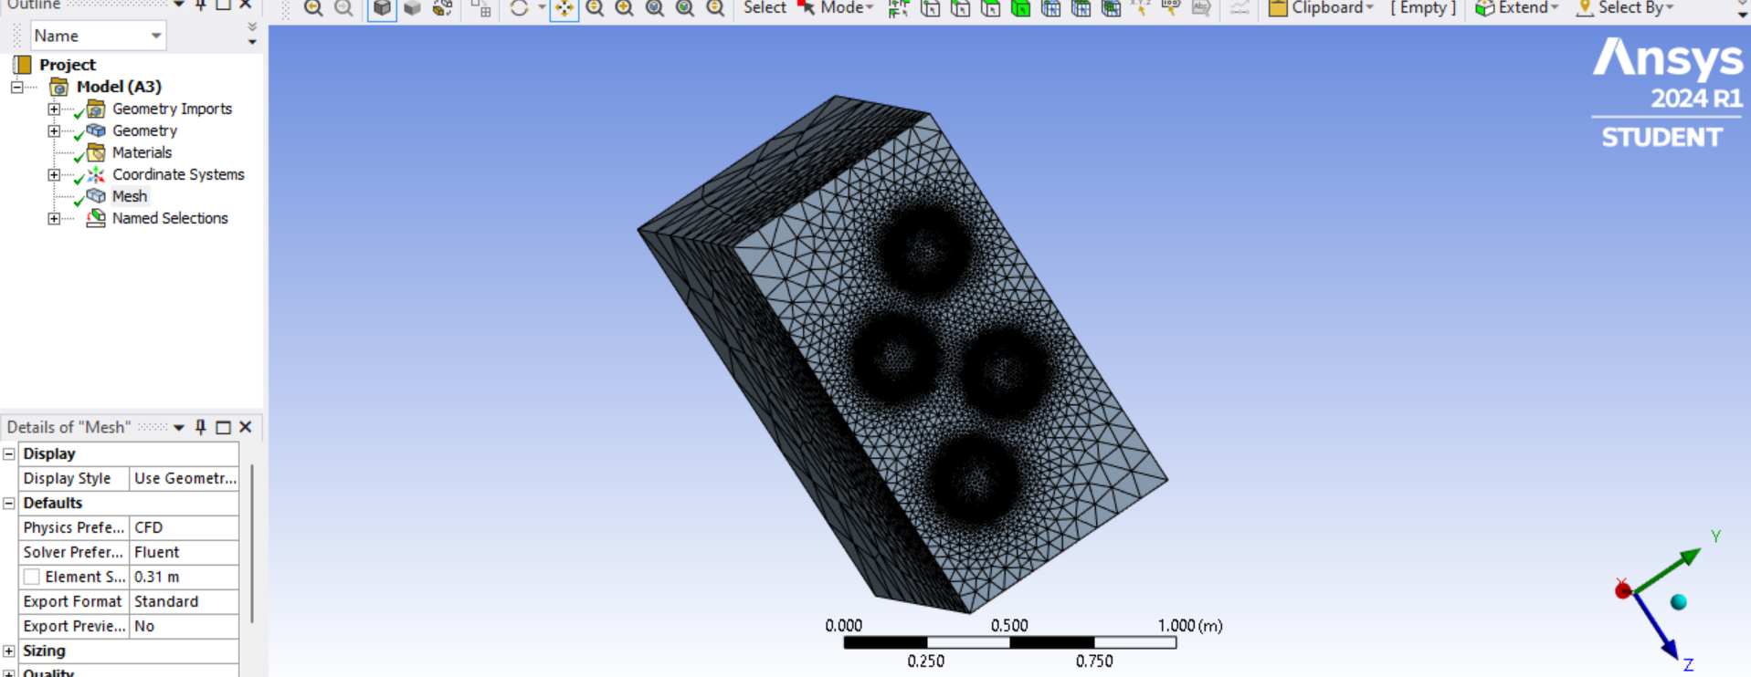

Now by naming the inlet,wall and outlet to the nozzle and domain move to setup.



Solver type -Pressure based

Velocity formulation-Absolute

Time-Steady

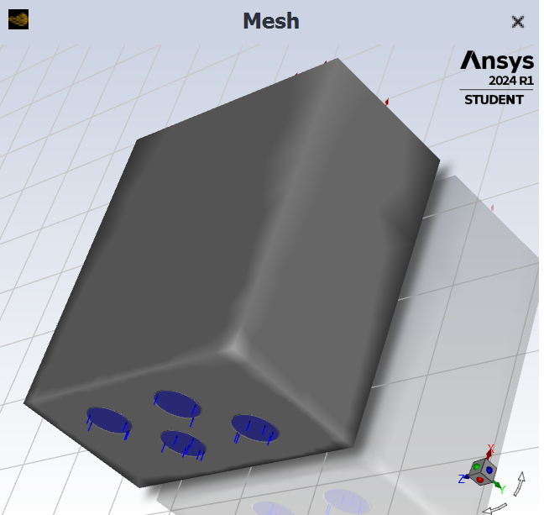





With temperature taken as 3710k.



With backflow total temperature as 300k.





With standard initialization across inlet and reference frame relative to cell zone conditions the parameters are given as:



